**Online Car Rental System**

**Abstract**:

We developed this project to book a car on rent at the fare charges. In present system all booking work done manually and it takes extremely hard work to maintain the information of booking and cars. If you want to find which vehicle is available for booking, then it takes a lot of time. It only makes the process more difficult and harder. This aim of the project is to automate the work performed in the car rental management system like generating daily bookings, records of car or cab available for booking, record of routes available, rental charges for cars for every rout, store record of the customer. Car rental system is a car booking software that provides a complete solution to all your day-to-day car booking office running needs. This system helps you to keep the information of Customer online.

A car rental service is wishing to have a user interface that will allow their customers to view the models, descriptions and prices of different cars available. The user has the ability to register and log in to the web site and see their rental plan. The web site will be responsive, allowing for the customer to view it on any device, from tables to mobile phones and desktop computers. The administrator will also be able to login through the same from but have the ability to add/remove new car rentals, change prices, and so on. Potential customers should be able to view all the cars available to rent even without logging in as well as rent without having an account, through the option is provided upon checkout.

**Introduction**

Car rental or car hire agencies are private companies that provide short time leasing vehicles for a specified time with a fee to their customers. car rental service increasingly becomes the preferred option for most people, especially among students in campuses and universities. This occurs because not all students can afford having their own vehicle and perhaps the university bus service doesn’t always help. Besides, the raising taxi fares and inconsistent bus arrivals in Malaysia continue to discourage people from taking up the public transport. Many organizations used web-based system because most people often used mobile phone that gives convenience to the users who are familiar with web technology. The technology has been implemented into the wide-range different sectors, such as education.

The project is designed to help people utilize transport effectively. In recent times cars have become most convenient modes of transportation. Our Car rental system helps in making this an easier, hassle-free and enjoyable experience to acquire and use a car as per ones needs. A person can book a car specifically for his travel time, co-travelers and the nature of travel. The rental system traverses from designing a database to understanding business concept and above all to make this an easy to adapt system for various travelling needs.

**Existing System**

In this system user (or) client will directly interact with the car owner and owner will decide whether the car is available or not. Then if it is available he will give rent a car to the customer. The main drawback of this system is customer need to meet the car owner .this is time waste process.

**Drawbacks**

* Car rental process is done manually.
* These tasks are time consuming.
* People around the world cannot book.
* Not accuracy and timeconsuming process.
* We may have less choices.

**Proposed System**

In this car rental system we are going to introduce online booking of car rent will be available. So the Burdon of the customer will be reduced. Our Aim is to design and create a data management System for a car rental company. This enables admin can rent a vehicle that can be used by a customer. By paying the money during a Specified Period of time. This system increases customer retention and simplify vehicle and staff Management in an efficient way.

**Advantages**

1 Its online system so that from anywhere can book the car and can take for rent

2. Friendly usage and budget friendly

3. We can cancel the booking at any time

4, We have more choices of cars

**Modules**

1. Administrator

2. Customers

**Scope and Objective Of the Project**

Car rental is a vehicle that can be used temporarily for a fee during a specified period. Getting a rental car helps people get around despite the fact they do not have access to their own personal vehicle or don’t own a vehicle at all. The individual who needs a car must contact a rental car company and contract out for a vehicle. This system increases customer retention and simplify vehicle and staff management.

**Hardware Configuration**

* Processor                    Intel I3 Processor
* RAM                          4 GB
* Monitor                      15 inch color monitor or LED
* Hard disk                    160 GB
* Key board                   Standard 102 keys
* Mouse                         Optical

**Software Configuration**

* Operating system       Windows
* IDE Eclipse
* Language                    Java
* Framework Jsp and JDBC
* Back End                      MYSQL
* Front End HTML,CSS,JS,Bootstrap
* Server Apache Tomcat

**Functional Requirements**

Admin functionalities

* Add cars
* View cars
* View bookings
* View customers
* Change password

Customer functionalities:

* View cars
* My bookings
* View customers
* Change password

**Non Functional Requirements:**

Non functional testing is a type of software testing that verifies non functional aspects of the product, such as performance, stability, and usability. Whereas functional testing verifies whether or not the product does what it is supposed to, non functional testing verifies how well the product performs.

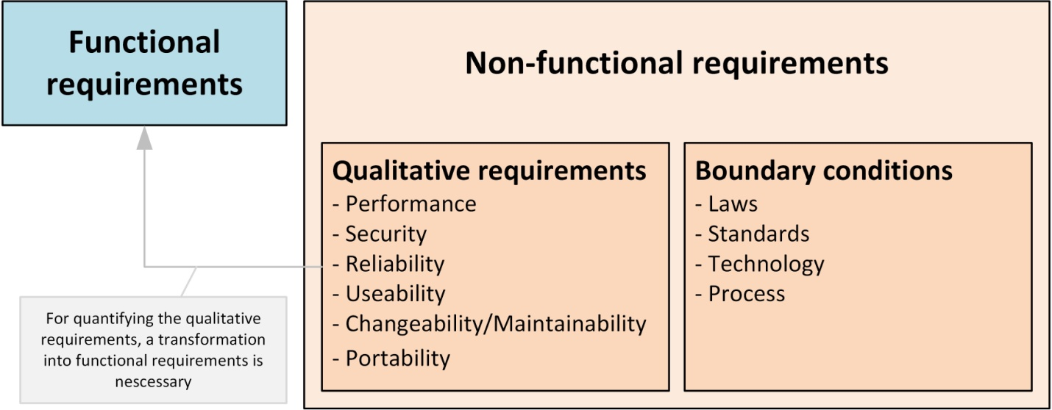

**The system should shows below non functional requirements**

1. High Security
2. Multi browser and operating system compatibility
3. Mobile responsiveness
4. High quality and performance
5. Memory optimized and User Friendliness
6. Easy maintenance and scalable capability
7. It's should support good accessibility and usability
8. It should follow regulatory and compliance policies

**Feasibility Study**

* The possibility of the undertaking is broke down during this stage and strategic plan is advanced with an exceptionally broad arrangement for the task and a few quotes. During project examination the likelihood investigation of the proposed project is to be completed. this is often to ensure that the proposed project isn't a weight to the organization. For practicality examination, some comprehension of the many necessities for the project is prime.
* After the approval of the request to the organization and project guide, with an investigation being considered, the project request must be examined to determine precisely what the system requires.
* Not all request projects are desirable or feasible. Some organization receives so many project requests from client users that only few of them are pursued. However, those projects that are both feasible and desirable should be put into schedule. After a project request is approved, it cost, priority, completion time and personnel requirement is estimated and used to determine where to add it to any project list. Truly speaking, the approval of those above factors, development works can be launched
* An important outcome of preliminary investigation is the determination that the system request is feasible. This is possible only if it is feasible within limited resource and time. The different feasibilities that have to be analyzed are.

**ECONOMICAL FEASIBILITY**

* This examination is completed to see the financial effect that the framework will wear the association. The measure of store that the organization can fill the innovative work of the framework is constrained. The consumptions must be advocated. Accordingly, the created framework also inside the budget and this was accomplished in light of the very fact that an outsized portion of the advancements utilized are uninhibitedly accessible. Just the modified items must be bought. Economic Feasibility or Cost-benefit is an assessment of the economic justification for a computer based project. As hardware was installed from the beginning & for lots of purposes thus the cost on project of hardware is low. And also in this project work all software is free and open source. It can be developed using our personal machines. So its economically its feasible to complete the project.

**TECHNICAL FEASIBILITY**

* According to Roger S. Pressman, Technical Feasibility is the assessment of the technical resources of the organization. The system is developed for platform Independent environment. The technical feasibility has been carried out. The system is technically feasible for development and can be developed with the existing facility.
* This investigation is completed to see the technical practicality, that is, the specialized prerequisites of the framework. Any framework created must not have a popularity on the accessible specialized assets. this may prompt high requests on the accessible specialized assets. this may prompt high requests being assail the customer. The created framework must have a humble prerequisite, as just insignificant or invalid changes are required for actualizing this framework.

**SOCIAL FEASIBILITY**

* The a part of study is to see the degree of acknowledgment of the framework by the client. This incorporates the way toward preparing the client to utilize the framework effectively. The client must not feel undermined by the framework, rather should acknowledge it as a requirement . The degree of acknowledgment by the clients exclusively relies upon the techniques that are utilized to show the client about the framework and to form him familiar with it. His degree of certainty must be raised with the goal that he's likewise able to make some helpful analysis, which is invited, as he's the last client of the framework.

**OPERATIONAL FEASIBILITY**

* This region of attainability ensures that the undertaking fulfills all the prerequisites that were talks about during introductory necessity examination stage. This undertaking met all the necessities proposed before. It ensured that the modules examined during the proposing of the framework were actualized with stable precision and with no mistakes.
* Operational Feasibility deals with the study of prospects of the system to be developed. This system operationally eliminates all the tensions of the Admin and helps him in effectively tracking the project progress. This kind of automation will surely reduce the time and energy, which previously consumed in manual work. Based on the study, the system is proved to be operationally feasible.

**Process Models:**

**1. Waterfall Model**

Waterfall model indicates that all the SDLC steps will be going on step by step. In this model once one stage completed then only it will start the another process. This will be implemented when the requirements well known and clearly defined.

In this model we can implement all the steps one by one. First we will do requirements gathering i.e in this step business analyst will collect the all functional requirements from the client and will discuss with the manager and development team. Second step is analysis where people can analyses the requirements so that they will do risk basement, risk mitigation, risk controlling steps. And also they will do the cost-time analysis to estimate the cost. They will also do the detail feasible study over the requirements of project.

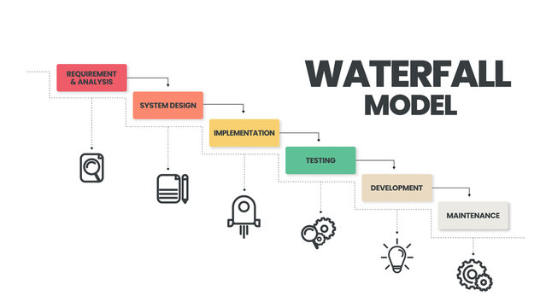

In third phase called design page generally people will design the project i.e architect will prepare the UML diagrams and prototypes for project. And then developers will start programming or coding based on design . Finally testing team will test the content to identify and fix the bugs. After successful user acceptance testing application will be deployed and maintained in the client machine.

The waterfall model was selected as the SDLC model due to the following reasons:

* When the requirements are very clear and not changed.
* Available technology is enough to implement.
* Project is easy and simple to understand to finish.
* And if we don’t have any confusion in requirements.
* We can easily manage the review process and task management.
* Every stage defined clearly and with timelines

**2. Agile Scrum Model**

Agile scrum methodology is the combination of the agile philosophy and the scrum framework. Agile means “incremental, allowing teams to develop projects in small increments. Scrum is one of the many types of agile methodology, known for breaking projects down into sizable chunks called “sprints.” Agile scrum methodology is good for businesses that need to finish specific projects quickly.

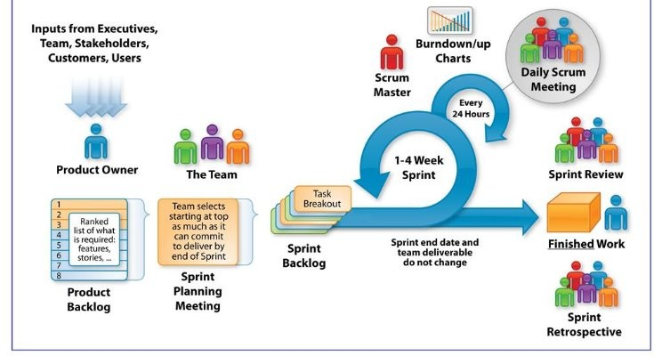

Agile scrum methodology is a [project management system](https://www.businessnewsdaily.com/15883-project-management-software.html) that relies on incremental development. Each iteration consists of two- to four-week sprints, where the goal of each sprint is to build the most important features first and come out with a potentially deliverable product. More features are built into the product in subsequent sprints and are adjusted based on stakeholder and customer feedback between sprints. Whereas other project management methods emphasize building an entire product in one operation from start to finish, agile scrum methodology focuses on delivering several iterations of a product to provide stakeholders with the highest business value in the least amount of time.

Agile scrum methodology has several benefits. First, it encourages products to be built faster, since each [set of goals](https://www.businessnewsdaily.com/11225-set-achievable-business-goals.html) must be completed within each sprint’s time frame. It also requires frequent planning and goal setting, which helps the scrum team focus on the current sprint’s objectives and increase productivity.

The greatest benefit of agile scrum methodology is its flexibility. With the sprint-based model, the scrum team typically receives feedback from stakeholders after each sprint. If there are any problems or changes, the scrum team can easily and quickly adjust product goals during future sprints to provide more valuable iterations. This way, stakeholders are happier because they get exactly what they want after being involved every step of the way.

**DESIGN:**

**INPUT DESIGN**

The input design is the link between the information system and the user. It comprises the developing specification and procedures for data preparation and those steps are necessary to put transaction data in to a usable form for processing can be achieved by inspecting the computer to read data from a written or printed document or it can occur by having people keying the data directly into the system. The design of input focuses on controlling the amount of input required, controlling the errors, avoiding delay, avoiding extra steps and keeping the process simple. The input is designed in such a way so that it provides security and ease of use with retaining the privacy. Input Design considered the following things:

* What data should be given as input?
* How the data should be arranged or coded?
* The dialog to guide the operating personnel in providing input.
* Methods for preparing input validations and steps to follow when error occur.

OBJECTIVES

1.Input Design is the process of converting a user-oriented description of the input into a computer-based system. This design is important to avoid errors in the data input process and show the correct direction to the management for getting correct information from the computerized system.

2. It is achieved by creating user-friendly screens for the data entry to handle large volume of data. The goal of designing input is to make data entry easier and to be free from errors. The data entry screen is designed in such a way that all the data manipulates can be performed. It also provides record viewing facilities.

3.When the data is entered it will check for its validity. Data can be entered with the help of screens. Appropriate messages are provided as when needed so that the user will not be in maize of instant. Thus the objective of input design is to create an input layout that is easy to follow

**OUTPUT DESIGN**

A quality output is one, which meets the requirements of the end user and presents the information clearly. In any system results of processing are communicated to the users and to other system through outputs. In output design it is determined how the information is to be displaced for immediate need and also the hard copy output. It is the most important and direct source information to the user. Efficient and intelligent output design improves the system’s relationship to help user decision-making.

1. Designing computer output should proceed in an organized, well thought out manner; the right output must be developed while ensuring that each output element is designed so that people will find the system can use easily and effectively. When analysis design computer output, they should Identify the specific output that is needed to meet the requirements.

2.Select methods for presenting information.

3.Create document, report, or other formats that contain information produced by the system.

The output form of an information system should accomplish one or more of the following objectives.

* Convey information about past activities, current status or projections of the
* Future.
* Signal important events, opportunities, problems, or warnings.
* Trigger an action.
* Confirm an action.

**SYSTEM MODEL / UML Diagrams:**

This section consists of the UML diagrams related to the modules developed such as Activity diagram, Sequence diagram and Use case diagram.

UML stands for Unified Modeling Language. UML is a standardized general-purpose modeling language in the field of object-oriented software engineering. The standard is managed, and was created by, the Object Management Group.

The goal is for UML to become a common language for creating models of object oriented computer software. In its current form UML is comprised of two major components: a Meta-model and a notation. In the future, some form of method or process may also be added to; or associated with, UML.

The Unified Modeling Language is a standard language for specifying, Visualization, Constructing and documenting the artifacts of software system, as well as for business modeling and other non-software systems.

The UML represents a collection of best engineering practices that have proven successful in the modeling of large and complex systems.

The UML is a very important part of developing objects oriented software and the software development process. The UML uses mostly graphical notations to express the design of software projects.

**GOALS:**

The Primary goals in the design of the UML are as follows:

* Provide users a ready-to-use, expressive visual modeling Language so that they can develop and exchange meaningful models.
* Provide extendibility and specialization mechanisms to extend the core concepts.
* Be independent of particular programming languages and development process.
* Provide a formal basis for understanding the modelling language.
* Encourage the growth of OO tools market.
* Support higher level development concepts such as collaborations, frameworks, patterns and components.
* Integrate best practices.

**Sequence Diagram**

A grouping outline in UML is a sort of association chart that shows how procedures work with each other and in what request. “It is a build of a Message Sequence Chart. Succession outlines are now and again called occasion charts, occasion situations, and timing graphs”.

**Admin-Sequence Diagram:**

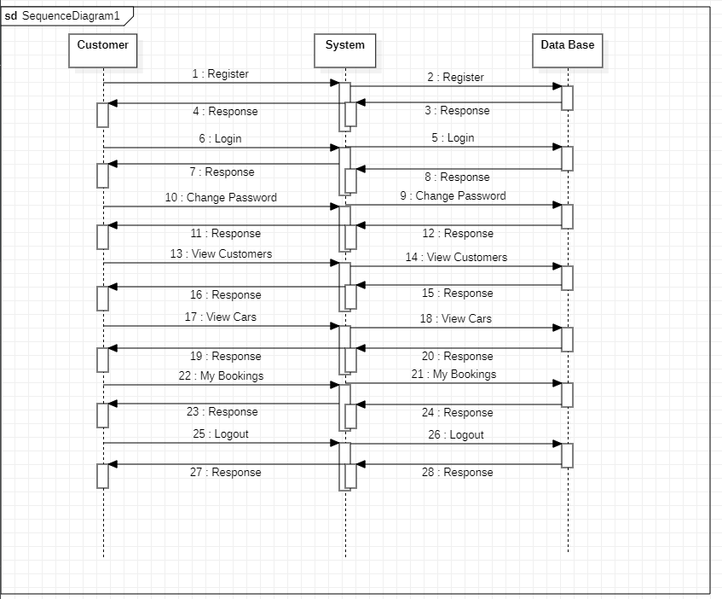

**Customer-Sequence Diagram:**

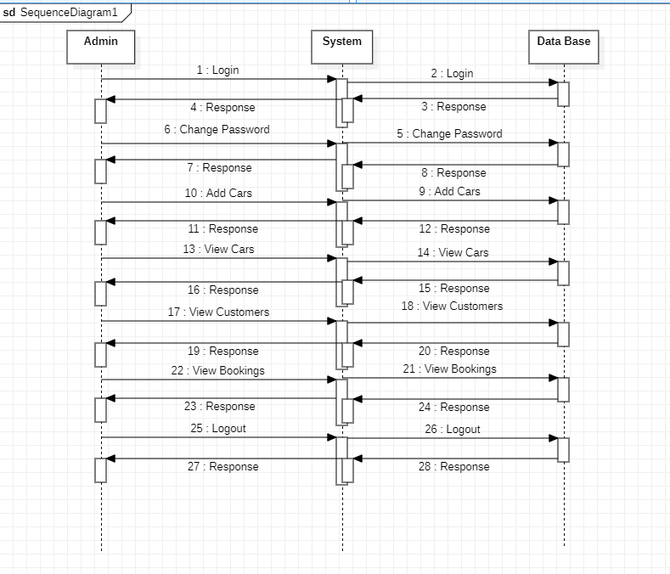

**Use Case Diagram**

An utilization case outline in the UML is a sort of conduct graph characterized by and made from a Use-case examination. Its motivation is to introduce a graphical diagram of the usefulness given by a framework regarding on-screen characters, their objectives (spoke to as use cases), and any conditions between those utilization cases. The fundamental motivation behind an utilization case outline is to indicate what framework capacities are performed for which on-screen character. Jobs of the on-screen characters in the framework can be delineated”.

**Admin-Use Case Diagram:**

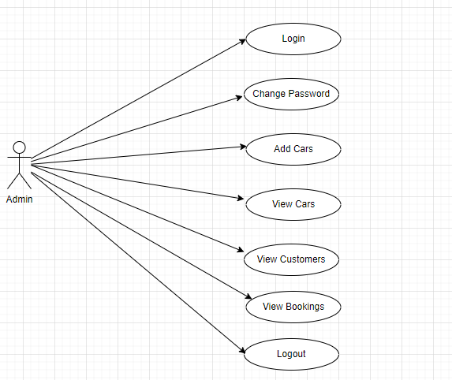

**Customer-Use Case Diagram:**

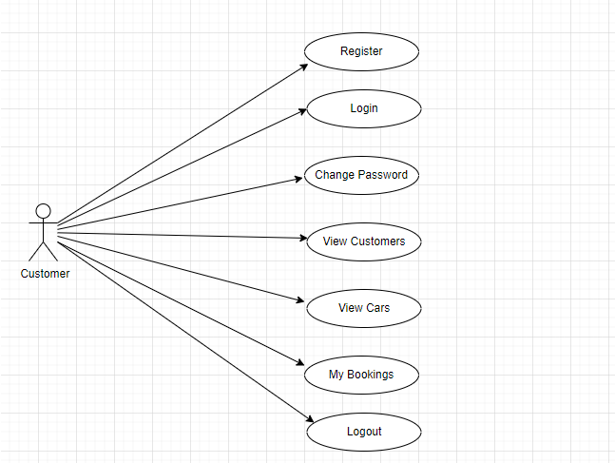

**Activity Diagram**

“Movement charts are graphical portrayals of work processes of stepwise exercises and activities with help for decision, emphasis and simultaneousness. In the Unified Modeling Language, movement graphs can be utilized to depict the business and operational bit by bit work processes of parts in a framework. A movement chart demonstrates the general progression of control”.

**Admin-Activity Diagram:**

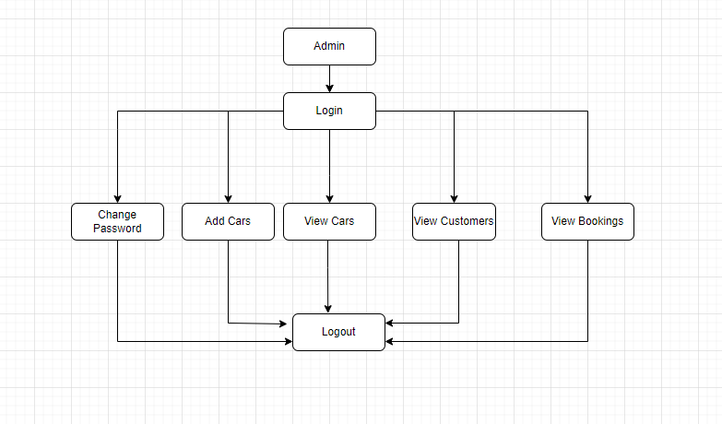

**Customer-Activity Diagram:**

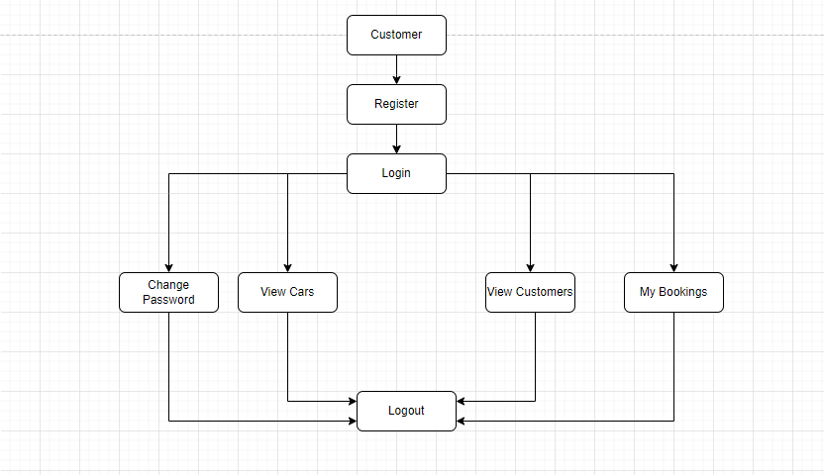

**Component Diagram**

The component diagram is a special purpose diagram, which is used to visualize the static implementation view of a system. It represents the physical components of a system, or we can say it portrays the organization of the components inside a system. The components, such as libraries, files, executables, etc.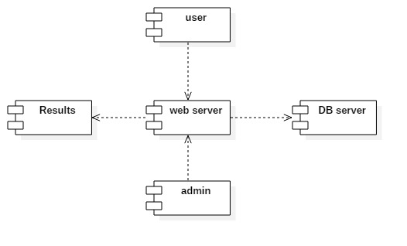

**Deployment Diagram**

A deployment diagram is a UML diagram type that shows the execution architecture of a system, including nodes such as hardware or software execution environments, and the middleware connecting them. Deployment diagrams are typically used to visualize the physical hardware and software of a system

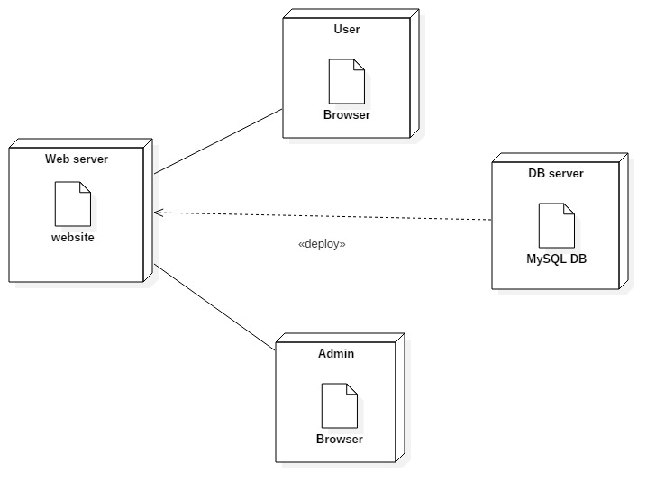

**Class Diagram:**

Class diagram is a static diagram. It represents the static view of an application. Class diagram is not only used for visualizing, describing, and documenting different aspects of a system but also for constructing executable code of the software application.

Class diagram describes the attributes and operations of a class and also the constraints imposed on the system. The class diagrams are widely used in the modeling of object oriented systems because they are the only UML diagrams, which can be mapped directly with object-oriented languages.

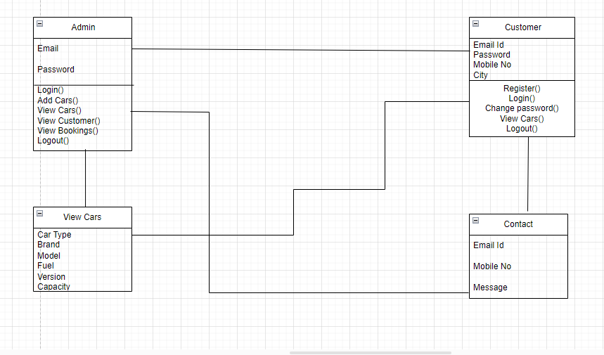

**ER Diagram**

An Entity Relationship (ER) Diagram is a type of flowchart that illustrates how “entities” such as people, objects or concepts relate to each other within a system. ER Diagrams are most often used to design or debug relational databases in the fields of software engineering, business information systems, education and research. Also known as ERDs or ER Models, they use a defined set of symbols such as rectangles, diamonds, ovals and connecting lines to depict the interconnectedness of entities, relationships and their attributes. They mirror grammatical structure, with entities as nouns and relationships as verbs.

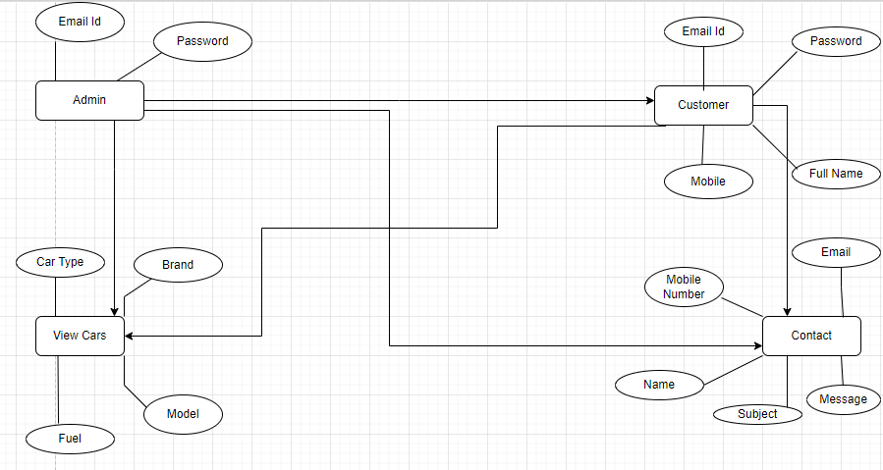

**Data Flow Diagram**

A data-flow diagram is a way of representing a flow of data through a process or a system. The DFD also provides information about the outputs and inputs of each entity and the process itself. A data-flow diagram has no control flow — there are no decision rules and no loops. A **data flow diagram** (DFD) maps out the flow of information for any process or system. It uses defined symbols like rectangles, circles and arrows,

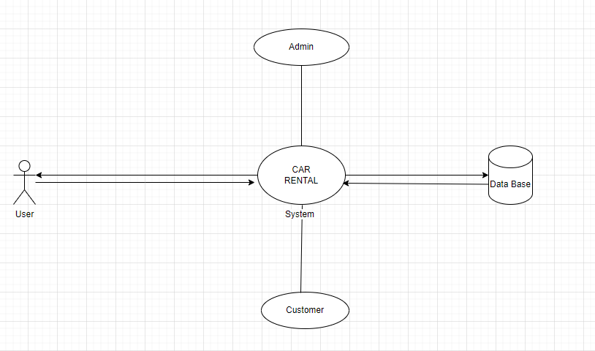

**ABOUT TECHNOLOGY:**

### The Java Programming Language

### The Java programming language is a high-level language that can be characterized by all of the following buzzwords:

* + - Simple
    - Architecture neutral
    - Object oriented
    - Portable
    - Distributed
    - High performance
    - Interpreted
    - Multithreaded
    - Robust
    - Dynamic
    - Secure

With most programming languages, you either compile or interpret a program so that you can run it on your computer. The Java programming language is unusual in that a program is both compiled and interpreted. With the compiler, first you translate a program into an intermediate language called Java byte codes —the platform-independent codes interpreted by the interpreter on the Java platform. The interpreter parses and runs each Java byte code instruction on the computer. Compilation happens just once; interpretation occurs each time the program is executed. The following figure illustrates how this works.

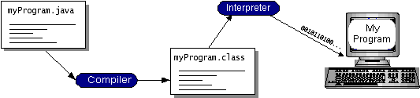

You can think of Java byte codes as the machine code instructions for the Java Virtual Machine (Java VM). Every Java interpreter, whether it’s a development tool or a Web browser that can run applets, is an implementation of the Java VM. Java byte codes help make “write once, run anywhere” possible. You can compile your program into byte codes on any platform that has a Java compiler. The byte codes can then be run on any implementation of the Java VM. That means that as long as a computer has a Java VM, the same program written in the Java programming language can run on Windows 2000, a Solaris workstation, or on an iMac.

Java Installation

Open google and search for java

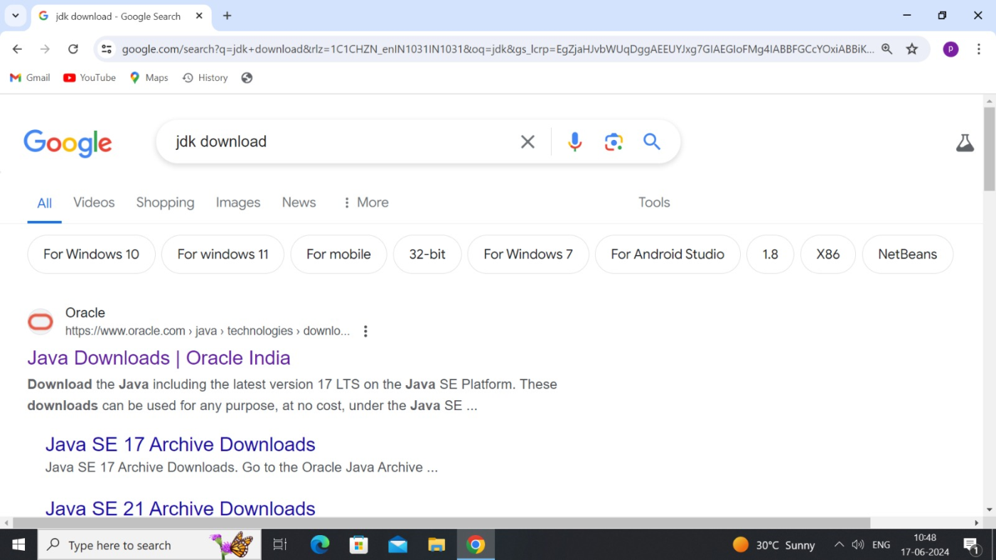

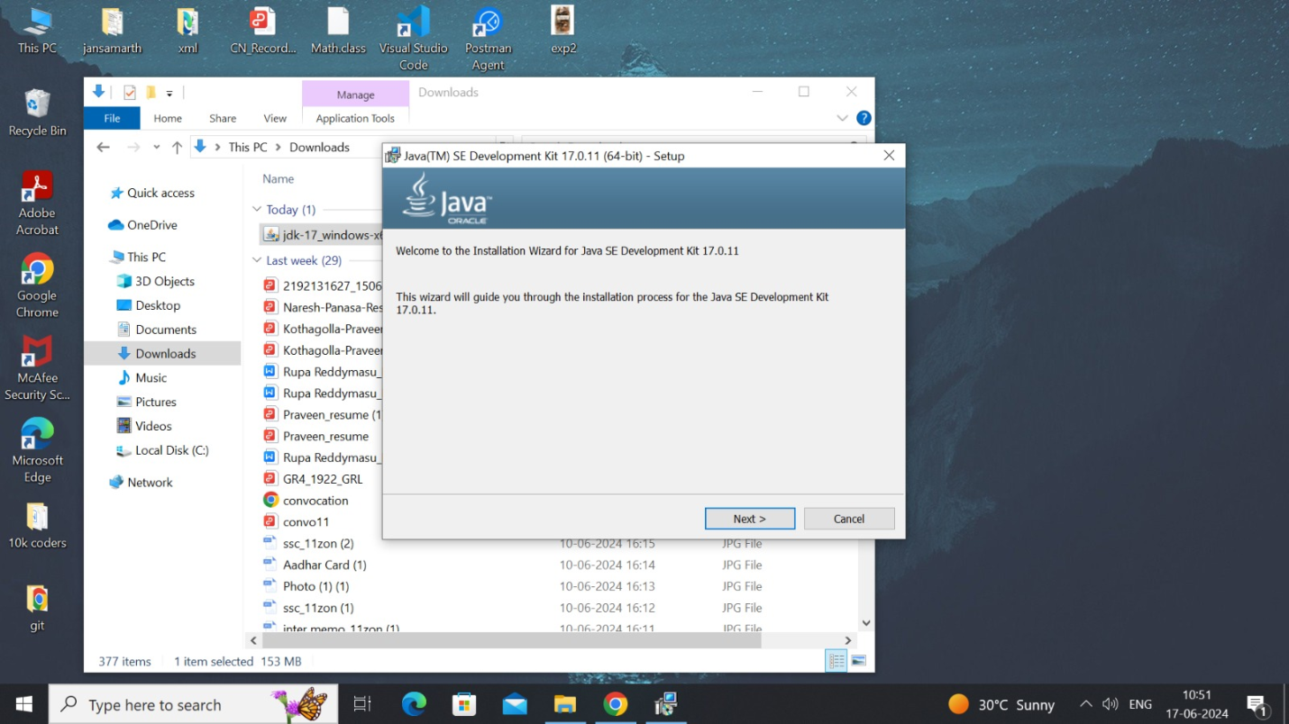

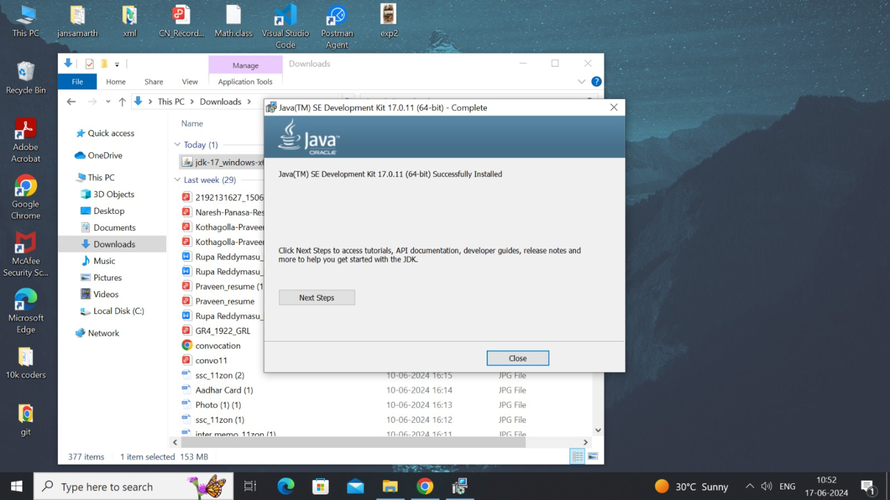

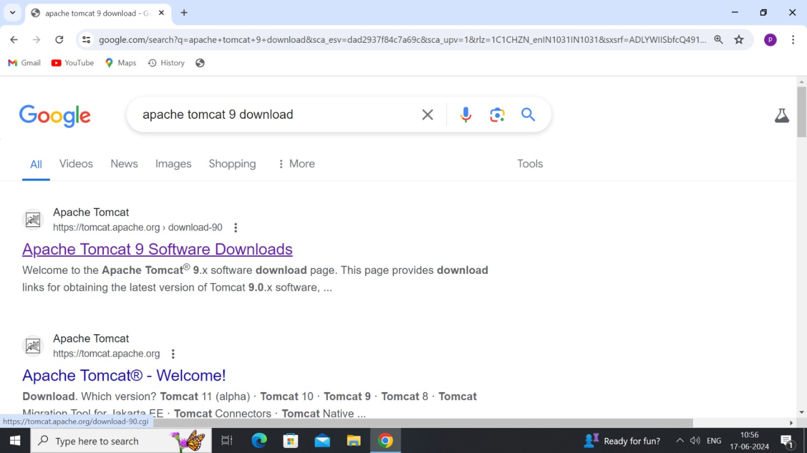

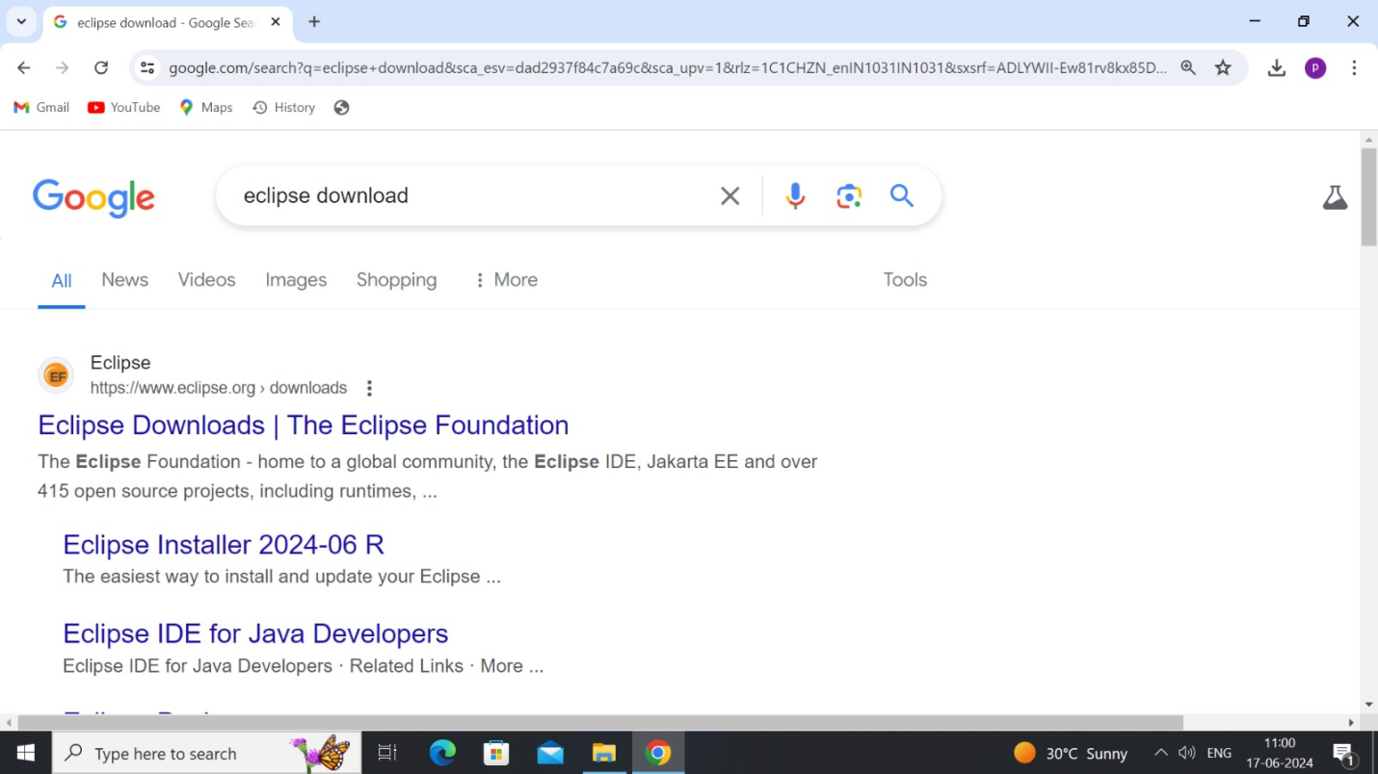

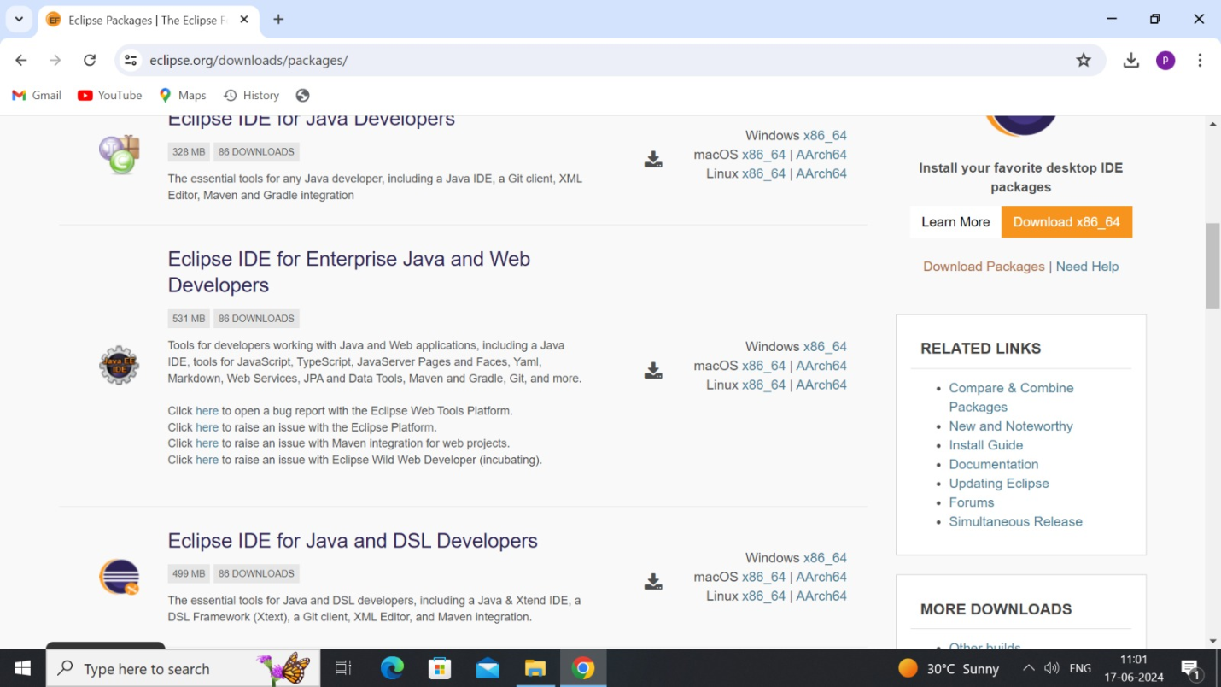

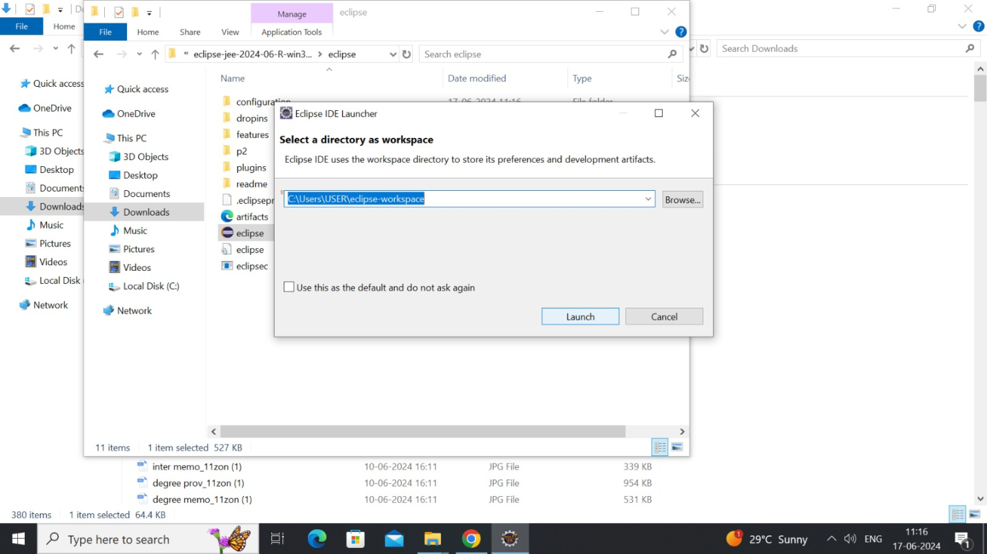

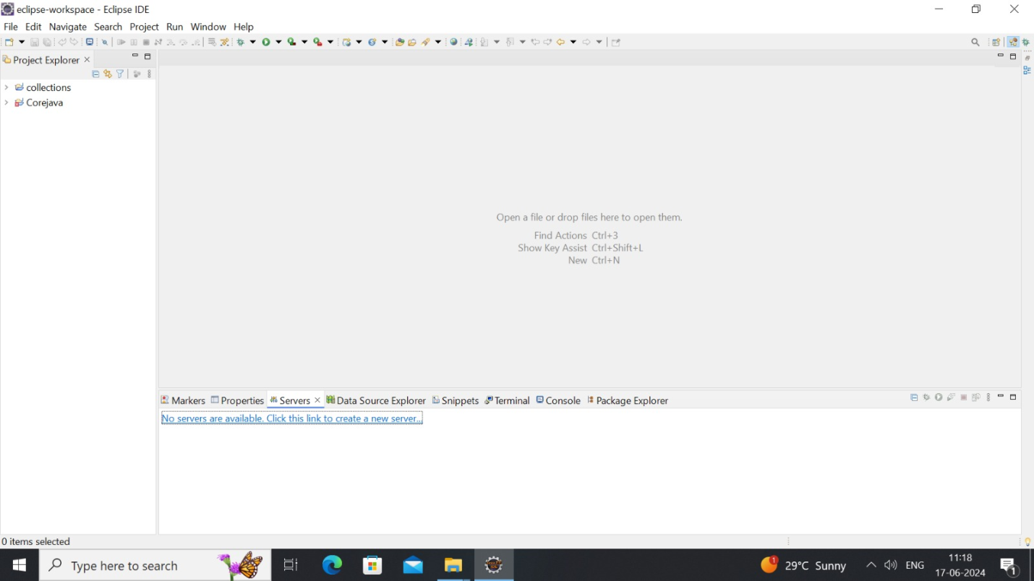

JSP

**JSP** technology is used to create web application just like Servlet technology. It can be thought of as an extension to Servlet because it provides more functionality than servlet such as expression language, JSTL, etc.

A JSP page consists of HTML tags and JSP tags. The JSP pages are easier to maintain than Servlet because we can separate designing and development. It provides some additional features such as Expression Language, Custom Tags, etc.

There are many advantages of JSP over the Servlet. They are as follows:

#### **1) Extension to Servlet**

JSP technology is the extension to Servlet technology. We can use all the features of the Servlet in JSP. In addition to, we can use implicit objects, predefined tags, expression language and Custom tags in JSP, that makes JSP development easy.

#### **2) Easy to maintain**

JSP can be easily managed because we can easily separate our business logic with presentation logic. In Servlet technology, we mix our business logic with the presentation logic.

#### **3) Fast Development: No need to recompile and redeploy**

If JSP page is modified, we don't need to recompile and redeploy the project. The Servlet code needs to be updated and recompiled if we have to change the look and feel of the application.

#### **4) Less code than Servlet**

In JSP, we can use many tags such as action tags, JSTL, custom tags, etc. that reduces the code. Moreover, we can use EL, implicit objects, etc.

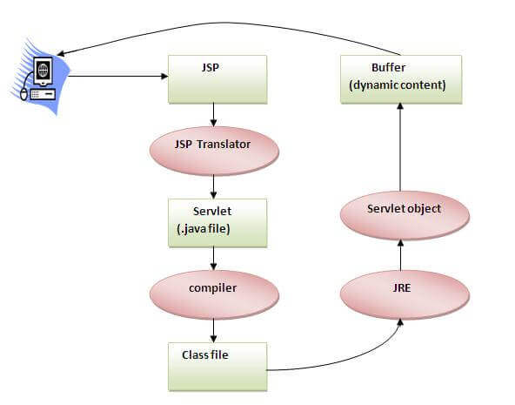

As depicted in the above diagram, JSP page is translated into Servlet by the help of JSP translator. The JSP translator is a part of the web server which is responsible for translating the JSP page into Servlet. After that, Servlet page is compiled by the compiler and gets converted into the class file. Moreover, all the processes that happen in Servlet are performed on JSP later like initialization, committing response to the browser and destroy.

JDBC

JDBC stands for Java Database Connectivity. JDBC is a Java API to connect and execute the query with the database. It is a part of JavaSE (Java Standard Edition). JDBC API uses JDBC drivers to connect with the database. We can use JDBC API to access tabular data stored in any relational database. By the help of JDBC API, we can save, update, delete and fetch data from the database. It is like Open Database Connectivity (ODBC) provided by Microsoft.

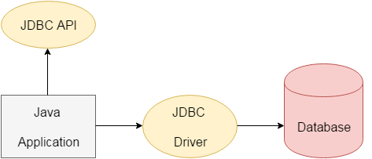

There are 5 steps to connect any java application with the database using JDBC. These steps are as follows:

* Register the Driver class
* Create connection
* Create statement
* Execute queries
* Close connection

Sample Code

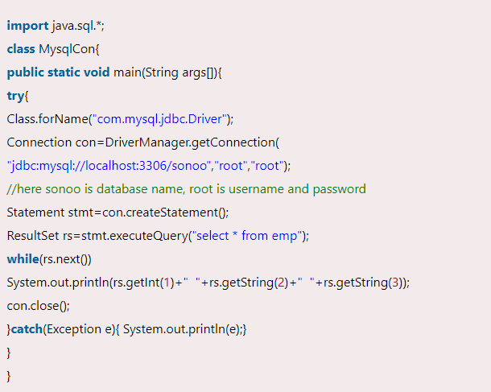

HTML:

Html is used to design the static web pages on web development. Static web page is that kind of web page, in which all the information and material is presented before users as it is exactly stored. Dynamic web page is web page where user can control the operations on website. Html is markup language to develop the web pages. It is basic web technology in web designing and which is used to develop the applications.

Html provides two types of content like input elements which are used to read the input from the user and semantic elements are used to display the data. We have different types of data elements to display the data and working on website.Html have different versions to manage the data efficiently.

CSS:

CSS is a cascading style sheet which will help you to style the webpage . we can apply the effects, styles, font-sizes , animations and others styles to web page. By using css3 we can develop the responsive web pages and we can develop the responsive website. Responsive website can open in the both mobile and browsers effectively.

It is mainly used to apply the color and effects more visibly to the webpage. It is attribute based language and which contains many attribute and value pairs to apply as styles. Css has three versions to apply the styles. It also have different framework like w3.css bootstrap to simplify the css style application.

CSS handles the seem and experience section of a internet page. Using CSS, you can manage the coloration of the text, the fashion of fonts, the spacing between paragraphs, how columns are sized and laid out, what heritage snap shots or colours are used, format designs, versions in show for extraordinary units and display sizes as properly as a range of different effects.CSS is convenient to analyze and recognize however it presents effective manipulate over the presentation of an HTML document.Define fashion sheet regulations immediately along-with the HTML elements the use of fashion attribute.You can practice fashion sheet guidelines without delay to any HTML factor the usage of styleattribute of the applicable tag. This need to be executed solely when you are involved to make a specific trade in any HTML component only.Rules described inline with the factor overrides the guidelines described in an exterior CSS file as nicely as the regulations described in <style> elementDefine fashion sheet guidelines in header part of the HTML record the usage of <style> tag.If you prefer to practice Style Sheet policies to a single file solely then you can encompass these regulations in header part of the HTML record the usage of <style> tag.Rules described in inside fashion sheet overrides the policies described in an exterior CSS file.With an exterior fashion sheet, you can trade the seem to be of an whole internet site by using altering simply one file!Each web page need to consist of a reference to the exterior fashion sheet file inner the <link> element. The <link> aspect goes inner the <head> section:</style>

Java script:

It is client-side scripting language which is used to apply the client-side operations and validations to the website. Java script code will be applied in browser itself. It will make the static web page as dynamic webpage in application.

It mainly used for validating the input data, performing minor mathematical operations, dynamic operations, dynamic styles and ajax request to server. Java script is acting as interface between html and php in the time of ajax request. It provides many events and functions to perform the operations on webpage so that static webpage will be converted as dynamic webpage. This code will run browser only and no need of server to install.

Javascript is a dynamic pc programming language. It is light-weight and most often used as a section of internet pages, whose implementations permit client-side script to engage with the consumer and make dynamic pages.

It is first carried out with the aid of Netscape (with assist from Sun Microsystems). JavaScript used to be created with the aid of Brendan Eich at Netscape in 1995 for the reason of permitting code in webpages.

Using HTML we can solely diagram a net web page however you can now not run any good judgment on internet browser like addition of two numbers, take a look at any condition, looping statements (for, while), choice making assertion (if-else) at consumer side. All these are no longer feasible the use of HTML So for function all these assignment at customer aspect you want to use JavaScript.

Comment is nothing however it is a declaration which is no longer show on browser window. it is beneficial to apprehend the which code is written for what purpose. Comments are beneficial in each programming language to supply message. It is used to add statistics about the code, warnings or guidelines so that the cease person or different developer can without problems interpret the code.

Client-side validation, Dynamic drop-down menus, Displaying information and time, Validate person enter in an HTML structure earlier than sending the records to a server, Build varieties that reply to consumer enter besides gaining access to a server, Change the look of HTML files and dynamically write HTML into separate Windows., Open and shut new windows or frames, Manipulate HTML "layers" which includes hiding, moving, and permitting the person to drag them round a browser window, Build small however entire patron facet packages , Displaying popup home windows and dialog packing containers (like alert dialog box, verify dialog container and instant dialog box), Displaying clocks etc.

MYSQL:

It is a relational database where we are storing the data in the form of relational tables and sql is used to communicate with database called mysql. Its mainly used to store the data and retrieve the data from the user.It is any kind of environment where we are just interested in storing and organizing the data.A Database is a set of data, organized for easy access. Database is the actual data.DBMS is a software and collection of tools that manages the database. Structure data can be defined as any time to press any key on a keyboard it generate from symbol, that signal can be converted into a symbol on the standard output device, such kind of composition is called as structure data.Anything that is basically represented in the form of audio, video and pictures. So total information in the form of binary format. It is non acceptable data from standard input device. It needs a secondary device, it could be anything like scanner, and web camera, mike etc. such kind of data is called as unstructured dataControl files must be protected.

The database device in which the relationships amongst special tables are maintained is referred to as Relational Database Management System. Both RDBMS and DBMS are used to save statistics in bodily database.A relational records mannequin consists of indexes, keys, overseas keys, tables and their relationships with different tables.

**DATA DICTIONARY(TABLES):**

|  |
| --- |
| **care_rent** |

* admin
* book
* car
* customer
* payment

|  |  |
| --- | --- |
| **admin** |  |
|  |  |

|  |
| --- |
| **Fields** |

|  |  |  |  |  |  |  |  |  |
| --- | --- | --- | --- | --- | --- | --- | --- | --- |
| **Field** | **Type** | **Collation** | **Null** | **Key** | **Default** | **Extra** | **Privileges** | **Comment** |
| id | int | (NULL) | NO | PRI | (NULL) | auto_increment | select,insert,update,references |  |
| email | varchar(222) | utf8mb4_0900_ai_ci | YES |  | (NULL) |  | select,insert,update,references |  |
| password | varchar(222) | utf8mb4_0900_ai_ci | YES |  | (NULL) |  | select,insert,update,references |  |

|  |
| --- |
| **Indexes** |

|  |  |  |  |  |  |  |  |  |  |  |  |  |  |  |
| --- | --- | --- | --- | --- | --- | --- | --- | --- | --- | --- | --- | --- | --- | --- |
| **Table** | **Non unique** | **Key name** | **Seq in index** | **Column name** | **Collation** | **Cardinality** | **Sub part** | **Packed** | **Null** | **Index type** | **Comment** | **Index comment** | **Visible** | **Expression** |
| admin | 0 | PRIMARY | 1 | id | A | 1 | (NULL) | (NULL) |  | BTREE |  |  | YES | (NULL) |

Back

|  |  |
| --- | --- |
| **book** |  |
|  |  |

|  |
| --- |
| **Fields** |

|  |  |  |  |  |  |  |  |  |
| --- | --- | --- | --- | --- | --- | --- | --- | --- |
| **Field** | **Type** | **Collation** | **Null** | **Key** | **Default** | **Extra** | **Privileges** | **Comment** |
| id | int | (NULL) | NO | PRI | (NULL) | auto_increment | select,insert,update,references |  |
| email | varchar(999) | utf8mb4_0900_ai_ci | YES |  | (NULL) |  | select,insert,update,references |  |
| phone | varchar(10) | utf8mb4_0900_ai_ci | YES |  | (NULL) |  | select,insert,update,references |  |
| car_id | int | (NULL) | YES |  | (NULL) |  | select,insert,update,references |  |
| Deposite_amount | varchar(999) | utf8mb4_0900_ai_ci | YES |  | (NULL) |  | select,insert,update,references |  |
| book_date | varchar(999) | utf8mb4_0900_ai_ci | YES |  | (NULL) |  | select,insert,update,references |  |
| pickUp_point | varchar(999) | utf8mb4_0900_ai_ci | YES |  | (NULL) |  | select,insert,update,references |  |
| dropping_point | varchar(999) | utf8mb4_0900_ai_ci | YES |  | (NULL) |  | select,insert,update,references |  |
| address | varchar(999) | utf8mb4_0900_ai_ci | YES |  | (NULL) |  | select,insert,update,references |  |
| today_date | varchar(999) | utf8mb4_0900_ai_ci | YES |  | (NULL) |  | select,insert,update,references |  |
| status | varchar(999) | utf8mb4_0900_ai_ci | YES |  | (NULL) |  | select,insert,update,references |  |

|  |
| --- |
| **Indexes** |

|  |  |  |  |  |  |  |  |  |  |  |  |  |  |  |
| --- | --- | --- | --- | --- | --- | --- | --- | --- | --- | --- | --- | --- | --- | --- |
| **Table** | **Non unique** | **Key name** | **Seq in index** | **Column name** | **Collation** | **Cardinality** | **Sub part** | **Packed** | **Null** | **Index type** | **Comment** | **Index comment** | **Visible** | **Expression** |
| book | 0 | PRIMARY | 1 | id | A | 4 | (NULL) | (NULL) |  | BTREE |  |  | YES | (NULL) |

Back

|  |  |
| --- | --- |
| **car** |  |
|  |  |

|  |
| --- |
| **Fields** |

|  |  |  |  |  |  |  |  |  |
| --- | --- | --- | --- | --- | --- | --- | --- | --- |
| **Field** | **Type** | **Collation** | **Null** | **Key** | **Default** | **Extra** | **Privileges** | **Comment** |
| id | int | (NULL) | NO | PRI | (NULL) | auto_increment | select,insert,update,references |  |
| cartype | varchar(999) | utf8mb4_0900_ai_ci | YES |  | (NULL) |  | select,insert,update,references |  |
| brand | varchar(999) | utf8mb4_0900_ai_ci | YES |  | (NULL) |  | select,insert,update,references |  |
| model | varchar(999) | utf8mb4_0900_ai_ci | YES |  | (NULL) |  | select,insert,update,references |  |
| fuel | varchar(999) | utf8mb4_0900_ai_ci | YES |  | (NULL) |  | select,insert,update,references |  |
| type | varchar(999) | utf8mb4_0900_ai_ci | YES |  | (NULL) |  | select,insert,update,references |  |
| version | varchar(999) | utf8mb4_0900_ai_ci | YES |  | (NULL) |  | select,insert,update,references |  |
| capacity | int | (NULL) | YES |  | (NULL) |  | select,insert,update,references |  |
| mincost | double | (NULL) | YES |  | (NULL) |  | select,insert,update,references |  |
| maxcost | double | (NULL) | YES |  | (NULL) |  | select,insert,update,references |  |
| excost | double | (NULL) | YES |  | (NULL) |  | select,insert,update,references |  |
| depositcost | double | (NULL) | YES |  | (NULL) |  | select,insert,update,references |  |
| feactures | varchar(999) | utf8mb4_0900_ai_ci | YES |  | (NULL) |  | select,insert,update,references |  |
| image | longblob | (NULL) | YES |  | (NULL) |  | select,insert,update,references |  |
| TypeCar | varchar(999) | utf8mb4_0900_ai_ci | YES |  | (NULL) |  | select,insert,update,references |  |

|  |
| --- |
| **Indexes** |

|  |  |  |  |  |  |  |  |  |  |  |  |  |  |  |
| --- | --- | --- | --- | --- | --- | --- | --- | --- | --- | --- | --- | --- | --- | --- |
| **Table** | **Non unique** | **Key name** | **Seq in index** | **Column name** | **Collation** | **Cardinality** | **Sub part** | **Packed** | **Null** | **Index type** | **Comment** | **Index comment** | **Visible** | **Expression** |
| car | 0 | PRIMARY | 1 | id | A | 2 | (NULL) | (NULL) |  | BTREE |  |  | YES | (NULL) |

Back

|  |  |
| --- | --- |
| **customer** |  |
|  |  |

|  |
| --- |
| **Fields** |

|  |  |  |  |  |  |  |  |  |
| --- | --- | --- | --- | --- | --- | --- | --- | --- |
| **Field** | **Type** | **Collation** | **Null** | **Key** | **Default** | **Extra** | **Privileges** | **Comment** |
| id | int | (NULL) | NO | PRI | (NULL) | auto_increment | select,insert,update,references |  |
| name | varchar(999) | utf8mb4_0900_ai_ci | YES |  | (NULL) |  | select,insert,update,references |  |
| email | varchar(999) | utf8mb4_0900_ai_ci | YES |  | (NULL) |  | select,insert,update,references |  |
| password | varchar(999) | utf8mb4_0900_ai_ci | YES |  | (NULL) |  | select,insert,update,references |  |
| phone | varchar(10) | utf8mb4_0900_ai_ci | YES |  | (NULL) |  | select,insert,update,references |  |
| address | varchar(999) | utf8mb4_0900_ai_ci | YES |  | (NULL) |  | select,insert,update,references |  |
| pincode | varchar(6) | utf8mb4_0900_ai_ci | YES |  | (NULL) |  | select,insert,update,references |  |
| city | varchar(999) | utf8mb4_0900_ai_ci | YES |  | (NULL) |  | select,insert,update,references |  |
| drivingLicense | longblob | (NULL) | YES |  | (NULL) |  | select,insert,update,references |  |

|  |
| --- |
| **Indexes** |

|  |  |  |  |  |  |  |  |  |  |  |  |  |  |  |
| --- | --- | --- | --- | --- | --- | --- | --- | --- | --- | --- | --- | --- | --- | --- |
| **Table** | **Non unique** | **Key name** | **Seq in index** | **Column name** | **Collation** | **Cardinality** | **Sub part** | **Packed** | **Null** | **Index type** | **Comment** | **Index comment** | **Visible** | **Expression** |
| customer | 0 | PRIMARY | 1 | id | A | 1 | (NULL) | (NULL) |  | BTREE |  |  | YES | (NULL) |

Back

|  |  |
| --- | --- |
| **payment** |  |
|  |  |

|  |
| --- |
| **Fields** |

|  |  |  |  |  |  |  |  |  |
| --- | --- | --- | --- | --- | --- | --- | --- | --- |
| **Field** | **Type** | **Collation** | **Null** | **Key** | **Default** | **Extra** | **Privileges** | **Comment** |
| id | int | (NULL) | NO | PRI | (NULL) | auto_increment | select,insert,update,references |  |
| email | varchar(999) | utf8mb4_0900_ai_ci | YES |  | (NULL) |  | select,insert,update,references |  |
| book_id | int | (NULL) | YES |  | (NULL) |  | select,insert,update,references |  |
| payment_date | varchar(999) | utf8mb4_0900_ai_ci | YES |  | (NULL) |  | select,insert,update,references |  |
| car_id | int | (NULL) | YES |  | (NULL) |  | select,insert,update,references |  |
| extra_days | int | (NULL) | YES |  | (NULL) |  | select,insert,update,references |  |
| extra_kms | decimal(10,0) | (NULL) | YES |  | (NULL) |  | select,insert,update,references |  |
| actual_cost | double | (NULL) | YES |  | (NULL) |  | select,insert,update,references |  |
| actual_kms | double | (NULL) | YES |  | (NULL) |  | select,insert,update,references |  |
| deposite_amount | double | (NULL) | YES |  | (NULL) |  | select,insert,update,references |  |
| total_cost | double | (NULL) | YES |  | (NULL) |  | select,insert,update,references |  |
| more_kms | int | (NULL) | YES |  | (NULL) |  | select,insert,update,references |  |

|  |
| --- |
| **Indexes** |

|  |  |  |  |  |  |  |  |  |  |  |  |  |  |  |
| --- | --- | --- | --- | --- | --- | --- | --- | --- | --- | --- | --- | --- | --- | --- |
| **Table** | **Non unique** | **Key name** | **Seq in index** | **Column name** | **Collation** | **Cardinality** | **Sub part** | **Packed** | **Null** | **Index type** | **Comment** | **Index comment** | **Visible** | **Expression** |
| payment | 0 | PRIMARY | 1 | id | A | 0 | (NULL) | (NULL) |  | BTREE |  |  | YES | (NULL) |

**SAMPLE CODE:**

Admin Login:

Front end code:

<!doctype html>

<html lang=*"en"*>

<head>

<title>Car Rent &mdash; Free Website Template by Colorlib</title>

<meta charset=*"utf-8"*>

<meta name=*"viewport"* content=*"width=device-width, initial-scale=1, shrink-to-fit=no"*>

<link href=*"https://fonts.googleapis.com/css?family=DM+Sans:300,400,700&display=swap"* rel=*"stylesheet"*>

<link rel=*"stylesheet"* href=*"fonts/icomoon/style.css"*>

<link rel=*"stylesheet"* href=*"css/bootstrap.min.css"*>

<link rel=*"stylesheet"* href=*"css/bootstrap-datepicker.css"*>

<link rel=*"stylesheet"* href=*"css/jquery.fancybox.min.css"*>

<link rel=*"stylesheet"* href=*"css/owl.carousel.min.css"*>

<link rel=*"stylesheet"* href=*"css/owl.theme.default.min.css"*>

<link rel=*"stylesheet"* href=*"fonts/flaticon/font/flaticon.css"*>

<link rel=*"stylesheet"* href=*"css/aos.css"*>

<!-- MAIN CSS -->

<link rel=*"stylesheet"* href=*"css/style.css"*>

</head>

<body data-spy=*"scroll"* data-target=*".site-navbar-target"* data-offset=*"300"*>

<div class=*"site-wrap"* id=*"home-section"*>

<div class=*"site-mobile-menu site-navbar-target"*>

<div class=*"site-mobile-menu-header"*>

<div class=*"site-mobile-menu-close mt-3"*>

<span class=*"icon-close2 js-menu-toggle"*></span>

</div>

</div>

<div class=*"site-mobile-menu-body"*></div>

</div>

<%@ include file=*"Homeheader.jsp"* %>

<div class=*"ftco-blocks-cover-1"*>

<div class=*"ftco-cover-1 overlay innerpage"* style="background-image: *url('images/hero_2.jpg')*">

<div class=*"container"*>

<div class=*"row align-items-center justify-content-center"*>

<div class=*"col-lg-6 text-center"*>

<h1>Admin_Login</h1>

</div>

</div>

</div>

</div>

</div>

<div class=*"site-section bg-light"* id=*"contact-section"*>

<div class=*"container"*>

<div class=*" justify-content-center text-center"*>

<div class=*"col-9 text-center "*>

<h2>Admin Login</h2>

</div>

</div>

<div class=*"row justify-content-center text-center"*>

<div class=*"col-lg-8 mb-5"* >

<form action=*"adlogindata.jsp"* method=*"post"*>

<div class=*"form-group row"*>

<div class=*"col-md-8 mb-6 mb-lg-0 text-center "*>

<input type=*"text"* class=*"form-control"* name=*"email"* placeholder=*"Email address"*>

</div>

</div>

<div class=*"form-group row"*>

<div class=*"col-md-8 mb-6 mb-lg-0"*>

<input type=*"text"* class=*"form-control"* name=*"password"* placeholder=*"Enter Password"*>

</div>

</div>

<div class=*"form-group row"*>

<div class=*"col-md-2 mr-auto text-center"*>

<input type=*"submit"* class=*"btn btn-block btn-primary text-white py-1 px-1"* value=*"Login"*>

</div>

</div>

</form>

</div>

</div></div></div>

<%@ include file=*"footer.jsp"* %>

</div>

<script src=*"js/jquery-3.3.1.min.js"*></script>

<script src=*"js/popper.min.js"*></script>

<script src=*"js/bootstrap.min.js"*></script>

<script src=*"js/owl.carousel.min.js"*></script>

<script src=*"js/jquery.sticky.js"*></script>

<script src=*"js/jquery.waypoints.min.js"*></script>

<script src=*"js/jquery.animateNumber.min.js"*></script>

<script src=*"js/jquery.fancybox.min.js"*></script>

<script src=*"js/jquery.easing.1.3.js"*></script>

<script src=*"js/bootstrap-datepicker.min.js"*></script>

<script src=*"js/aos.js"*></script>

<script src=*"js/main.js"*></script>

</body>

</html>

Back End Code:

<%@ page language=*"java"* contentType=*"text/html; charset=ISO-8859-1"*

pageEncoding=*"ISO-8859-1"* import=*"java.sql.*"*%>

<%@ include file=*"connect.jsp"* %>

<!DOCTYPE html>

<html>

<head>

<meta charset=*"ISO-8859-1"*>

<title>Insert title here</title>

</head>

<body>

<%

String email=request.getParameter("email");

String password=request.getParameter("password");

session.setAttribute("email", email);

**try** {

Statement st=con.createStatement();

ResultSet rss=st.executeQuery("select * from admin where email='"+email+"' and password='"+password+"'");

**if**(rss.next()) {

%>

<script>alert("LoginSucess")</script>

<jsp:include page=*"adminhome.jsp"* />

<%

}

**else** {

%>

<script>alert("LoginUnSucess")</script>");

<jsp:include page=*"admin.jsp"* />

<%

}

}**catch**(Exception e) {

e.printStackTrace();

}

%>

</body>

</html>

Add Cars:

<!doctype html>

<html lang=*"en"*>

<head>

<title>Car Rent &mdash; Free Website Template by Colorlib</title>

<meta charset=*"utf-8"*>

<meta name=*"viewport"* content=*"width=device-width, initial-scale=1, shrink-to-fit=no"*>

<link href=*"https://fonts.googleapis.com/css?family=DM+Sans:300,400,700&display=swap"* rel=*"stylesheet"*>

<link rel=*"stylesheet"* href=*"fonts/icomoon/style.css"*>

<link rel=*"stylesheet"* href=*"css/bootstrap.min.css"*>

<link rel=*"stylesheet"* href=*"css/bootstrap-datepicker.css"*>

<link rel=*"stylesheet"* href=*"css/jquery.fancybox.min.css"*>

<link rel=*"stylesheet"* href=*"css/owl.carousel.min.css"*>

<link rel=*"stylesheet"* href=*"css/owl.theme.default.min.css"*>

<link rel=*"stylesheet"* href=*"fonts/flaticon/font/flaticon.css"*>

<link rel=*"stylesheet"* href=*"css/aos.css"*>

<!-- MAIN CSS -->

<link rel=*"stylesheet"* href=*"css/style.css"*>

</head>

<body data-spy=*"scroll"* data-target=*".site-navbar-target"* data-offset=*"300"*>

<div class=*"site-wrap"* id=*"home-section"*>

<div class=*"site-mobile-menu site-navbar-target"*>

<div class=*"site-mobile-menu-header"*>

<div class=*"site-mobile-menu-close mt-3"*>

<span class=*"icon-close2 js-menu-toggle"*></span>

</div>

</div>

<div class=*"site-mobile-menu-body"*></div>

</div>

<%@ include file=*"adminheader.jsp"* %>

<div class=*"ftco-blocks-cover-1"*>

<div class=*"ftco-cover-1 overlay innerpage"* style="background-image: *url('images/hero_2.jpg')*">

<div class=*"container"*>

<div class=*"row align-items-center justify-content-center"*>

<div class=*"col-lg-6 text-center"*>

<h1>Add_Cars</h1>

</div>

</div>

</div>

</div>

</div>

<div class=*"site-section bg-light"* id=*"contact-section"*>

<div class=*"container"*>

<div class=*" justify-content-center text-center"*>

<div class=*"col-9 text-center "*>

<h2>Add_Cars</h2>

</div>

</div>

<div class=*"row justify-content-center text-center"*>

<div class=*"col-lg-8 mb-5"* >

<form action=*"adcardata.jsp"* method=*"post"* enctype=*"multipart/form-data"*>

<div class=*"form-group row"*>

<select name=*"typeCar"* class=*"col-md-7 mb-8 mb-lg-0"* class=*"form-group row"*>

<option value=*"Kia"*>Car</option>

<option value=*"audi"*>Jeep</option>

<option value=*"sukuki"*>Toofan</option>

</select>

</div>

<div class=*"form-group row"*>

<select name=*"cartype"* class=*"col-md-7 mb-6 mb-lg-0"* class=*"form-group row"*>

<option value=*"Kia"*>KIA</option>

<option value=*"audi"*>AUDI</option>

<option value=*"sukuki"*>SUZUKI</option>

<option value=*"honda"*>HONDA</option>

<option value=*"mahidhra"*>MAHINDHRA</option>

</select>

</div>

<div class=*"form-group row"*>

<div class=*"col-md-8 mb-6 mb-lg-0 text-center "*>

<input type=*"text"* class=*"form-control"* name=*"brand"* placeholder=*"Enter Brand"*>

</div>

</div>

<div class=*"form-group row"*>

<div class=*"col-md-8 mb-6 mb-lg-0"*>

<input type=*"text"* class=*"form-control"* name=*"model"* placeholder=*"Enter Model"*>

</div>

</div>

<div class=*"form-group row"*>

<select name=*"fuel"* class=*"col-md-7 mb-6 mb-lg-0"* class=*"form-group row"*>

<option value=*"Petrol"*>Petrol</option>

<option value=*"Diesel"*>Diesel</option>

<option value=*"Diesel"*>Electrical</option>

</select>

</div>

<div class=*"form-group row"*>

<div class=*"col-md-8 mb-6 mb-lg-0"*>

<input type=*"text"* class=*"form-control"* name=*"version"* placeholder=*"Enter version"*>

</div>

</div>

<div class=*"form-group row"*>

<select name=*"type"* class=*"col-md-7 mb-6 mb-lg-0"* class=*"form-group row"*>

<option value=*"Ac"*>AC</option>

<option value=*"Non-Ac"*>Non-AC</option>

</select>

</div>

<div class=*"form-group row"*>

<div class=*"col-md-8 mb-6 mb-lg-0"*>

<input type=*"number"* class=*"form-control"* name=*"capacity"* placeholder=*"Enter Capacity"*>

</div>

</div>

<div class=*"form-group row"*>

<div class=*"col-md-8 mb-6 mb-lg-0"*>

<input type=*"number"* class=*"form-control"* name=*"mincost"* placeholder=*"Enter Cost per/day"*>

</div>

</div>

<div class=*"form-group row"*>

<div class=*"col-md-8 mb-6 mb-lg-0"*>

<input type=*"number"* class=*"form-control"* name=*"maxcost"* placeholder=*"Enter Max Km/day"*>

</div>

</div>

<div class=*"form-group row"*>

<div class=*"col-md-8 mb-6 mb-lg-0"*>

<input type=*"number"* class=*"form-control"* name=*"excost"* placeholder=*"Cost per Extra Km"*>

</div>

</div>

<div class=*"form-group row"*>

<div class=*"col-md-8 mb-6 mb-lg-0"*>

<input type=*"number"* class=*"form-control"* name=*"decost"* placeholder=*"Deposit for Car"*>

</div>

</div>

<div class=*"form-group row"*>

<div class=*"col-md-8 mb-6 mb-lg-0"*>

<textarea class=*"form-control"* name=*"feactures"* placeholder=*"Enter feactures"*></textarea>

</div>

</div>

<div class=*"form-group row"*>

<div class=*"col-md-8 mb-6 mb-lg-0"*>

<label for=*"myfile"*>Select a file:</label>

<input type=*"file"* id=*"myfile"* name=*"carpic"*><br><br>

</div>

</div>

<div class=*"form-group row"*>

<div class=*"col-md-2 mr-auto text-center"*>

<input type=*"submit"* class=*"btn btn-block btn-primary text-white py-1 px-1"* value=*"Add Car"*>

</div>

</div>

</form>

</div>

</div></div></div>

<%@ include file=*"footer.jsp"* %>

</div>

<script src=*"js/jquery-3.3.1.min.js"*></script>

<script src=*"js/popper.min.js"*></script>

<script src=*"js/bootstrap.min.js"*></script>

<script src=*"js/owl.carousel.min.js"*></script>

<script src=*"js/jquery.sticky.js"*></script>

<script src=*"js/jquery.waypoints.min.js"*></script>

<script src=*"js/jquery.animateNumber.min.js"*></script>

<script src=*"js/jquery.fancybox.min.js"*></script>

<script src=*"js/jquery.easing.1.3.js"*></script>

<script src=*"js/bootstrap-datepicker.min.js"*></script>

<script src=*"js/aos.js"*></script>

<script src=*"js/main.js"*></script>

</body>

</html>

Back end code:

<%@ page language=*"java"* contentType=*"text/html; charset=ISO-8859-1"*

pageEncoding=*"ISO-8859-1"* import=*"java.sql.*"*%>

<%@ include file=*"connect.jsp"* %>

<%@page import=*"com.oreilly.servlet.*,java.sql.*,java.lang.*,java.text.SimpleDateFormat,java.util.*,java.io.*,javax.servlet.*,javax.servlet.http.*"* %>

<!DOCTYPE html>

<html>

<head>

<meta charset=*"ISO-8859-1"*>

<title>Insert title here</title>

</head>

<body>

<%

String typeCar=**null**;

String cartype=**null**;

String brand=**null**;

String model=**null**;

String fuel=**null**;

String type=**null**;

String version=**null**;

Integer capacity=0;

Double mincost=0.0;

Double maxcost= 0.0;

Double excost=0.0;

Double decost=0.0;

String feactures=**null**;

String image=**null**;

ArrayList list = **new** ArrayList();

ServletContext context = getServletContext();

String dirName =context.getRealPath("Gallery\\");

String paramname=**null**;

String file=**null**;

String bin = "";

FileInputStream fs=**null**;

File file1 = **null**;

**try** {

MultipartRequest multi = **new** MultipartRequest(request, dirName, 10 * 1024 * 1024); // 10MB

Enumeration params = multi.getParameterNames();

**while** (params.hasMoreElements())

{

paramname = (String) params.nextElement();

**if**(paramname.equalsIgnoreCase("typeCar"))

{

typeCar=multi.getParameter(paramname);

}

**if**(paramname.equalsIgnoreCase("cartype"))

{

cartype=multi.getParameter(paramname);

}

**if**(paramname.equalsIgnoreCase("brand"))

{

brand=multi.getParameter(paramname);

}

**if**(paramname.equalsIgnoreCase("model"))

{

model=multi.getParameter(paramname);

}

**if**(paramname.equalsIgnoreCase("fuel"))

{

fuel=multi.getParameter(paramname);

}

**if**(paramname.equalsIgnoreCase("type"))

{

type=multi.getParameter(paramname);

}

**if**(paramname.equalsIgnoreCase("version"))

{

version=multi.getParameter(paramname);

}

**if**(paramname.equalsIgnoreCase("feactures"))

{

feactures=multi.getParameter(paramname);

}

**if**(paramname.equalsIgnoreCase("carpic"))

{

image=multi.getParameter(paramname);

}

**if**(paramname.equalsIgnoreCase("capacity"))

{

capacity=Integer.parseInt(multi.getParameter(paramname));

}

**if**(paramname.equalsIgnoreCase("mincost"))

{

mincost=Double.parseDouble(multi.getParameter(paramname));

}

**if**(paramname.equalsIgnoreCase("maxcost"))

{

maxcost=Double.parseDouble(multi.getParameter(paramname));

}

**if**(paramname.equalsIgnoreCase("excost"))

{

excost=Double.parseDouble(multi.getParameter(paramname));

}

**if**(paramname.equalsIgnoreCase("decost"))

{

decost=Double.parseDouble(multi.getParameter(paramname));

}

}

// image upload

**int** f = 0;

Enumeration files = multi.getFileNames();

**while** (files.hasMoreElements())

{

paramname = (String) files.nextElement();

**if**(paramname != **null**)

{

f = 1;

image = multi.getFilesystemName(paramname);

String fPath = context.getRealPath("Gallery\\"+image);

file1 = **new** File(fPath);

fs = **new** FileInputStream(file1);

list.add(fs);

String ss=fPath;

FileInputStream fis = **new** FileInputStream(ss);

StringBuffer sb1=**new** StringBuffer();

**int** i = 0;

**while** ((i = fis.read()) != -1) {

**if** (i != -1) {

//System.out.println(i);

String hex = Integer.toHexString(i);

// session.put("hex",hex);

sb1.append(hex);

// sb1.append(",");

String binFragment = "";

**int** iHex;

**for**(**int** i1= 0; i1 < hex.length(); i1++){

iHex = Integer.parseInt(""+hex.charAt(i1),16);

binFragment = Integer.toBinaryString(iHex);

**while**(binFragment.length() < 4){

binFragment = "0" + binFragment;

}

bin += binFragment;

//System.out.print(bin);

}

}

}

}

}

FileInputStream fs1 = **null**;

String query="insert into car(cartype,brand,model,fuel,type,version,capacity,mincost,maxcost,excost,depositcost,feactures,image,TypeCar)values(?,?,?,?,?,?,?,?,?,?,?,?,?,?)";

PreparedStatement ps=con.prepareStatement(query);

ps.setString(1, cartype);

ps.setString(2, brand);

ps.setString(3, model);

ps.setString(4, fuel);

ps.setString(5, type);

ps.setString(6, version);

ps.setInt(7, capacity);

ps.setDouble(8, mincost);

ps.setDouble(9, maxcost);

ps.setDouble(10, excost);

ps.setDouble(11, decost);

ps.setString(12, feactures);

ps.setBinaryStream(13, (InputStream)fs, (**int**)(file1.length()));

// image upload

**if**(f == 0)

ps.setObject(13,**null**);

**else** **if**(f == 12)

{

fs1 = (FileInputStream)list.get(0);

ps.setBinaryStream(13,fs1,fs1.available());

}

ps.setString(14,typeCar);

**int** a=ps.executeUpdate();

**if**(a>0){

%>

<jsp:forward page=*"viewcars.jsp"* />

<%

}

**else**{

%>

<script>alert("Add_UnSuccess")</script>");

<jsp:include page=*"cars.jsp"* />

<%

}}

**catch**(Exception e)

{

e.printStackTrace();

}

%>

</body>

</html>

View Cars:

<!doctype html>

<html lang=*"en"*>

<head>

<title>Car Rent &mdash; Free Website Template by Colorlib</title>

<meta charset=*"utf-8"*>

<meta name=*"viewport"* content=*"width=device-width, initial-scale=1, shrink-to-fit=no"*>

<link href=*"https://fonts.googleapis.com/css?family=DM+Sans:300,400,700&display=swap"* rel=*"stylesheet"*>

<link rel=*"stylesheet"* href=*"fonts/icomoon/style.css"*>

<link rel=*"stylesheet"* href=*"css/bootstrap.min.css"*>

<link rel=*"stylesheet"* href=*"css/bootstrap-datepicker.css"*>

<link rel=*"stylesheet"* href=*"css/jquery.fancybox.min.css"*>

<link rel=*"stylesheet"* href=*"css/owl.carousel.min.css"*>

<link rel=*"stylesheet"* href=*"css/owl.theme.default.min.css"*>

<link rel=*"stylesheet"* href=*"fonts/flaticon/font/flaticon.css"*>

<link rel=*"stylesheet"* href=*"css/aos.css"*>

<!-- MAIN CSS -->

<link rel=*"stylesheet"* href=*"css/style.css"*>

</head>

<body data-spy=*"scroll"* data-target=*".site-navbar-target"* data-offset=*"300"*>

<div class=*"site-wrap"* id=*"home-section"*>

<div class=*"site-mobile-menu site-navbar-target"*>

<div class=*"site-mobile-menu-header"*>

<div class=*"site-mobile-menu-close mt-3"*>

<span class=*"icon-close2 js-menu-toggle"*></span>

</div>

</div>

<div class=*"site-mobile-menu-body"*></div>

</div>

<%@ include file=*"adminheader.jsp"* %>

<%@ include file=*"connect.jsp"* %>

<%@ page import=*"java.sql.*"* %>

<div class=*"ftco-blocks-cover-1"*>

<div class=*"ftco-cover-1 overlay innerpage"* style="background-image: *url('images/hero_2.jpg')*">

<div class=*"container"*>

<div class=*"row align-items-center justify-content-center"*>

<div class=*"col-lg-6 text-center"*>

<h1>ViewCars</h1>

</div>

</div>

</div>

</div>

</div>

<br><br><br>

<div class=*"container"*>

<div class=*"row"*>

<%

String query="select * from car";

Statement st=con.createStatement();

ResultSet rs=st.executeQuery(query);

**while**(rs.next()){

**int** car_id=rs.getInt(1);

String carName=rs.getString(2);

String carBrand=rs.getString(3);

String carModel=rs.getString(4);

String carVersion=rs.getString(7);

**double** minCost=rs.getDouble(9);

**double** maxCost=rs.getDouble(10);

**double** extraCost=rs.getDouble(11);

**double** dptCost=rs.getDouble(12);

String feactures=rs.getString(13);

String fuelType=rs.getString(5);

String Ac_NonAc=rs.getString(6);

**int** capacity=rs.getInt(8);

String Type=rs.getString(15);

%>

<div class=*"col-lg-4 col-md-6 mb-4"*>

<div class=*"item-1"*>

<img src=*"image.jsp?id=*<%=car_id%>*"* style="width:*500px*; height:*300px*;" alt=*"Image"* class=*"img-fluid"*>

<div class=*"item-1-contents"*>

<div class=*"text-center"*>

<h3><a href=*"#"*><%=carName%>&nbsp<%=carBrand%>&nbsp<%=carModel%>&nbsp<%=carVersion%></a></h3>

<div class=*"rent-price"*>

<h8>CostPerday-<span>Rs&nbsp<%=minCost %> &nbsp,

MaxKm/day-&nbsp<%=maxCost %> &nbsp,

DepositCost- Rs&nbsp<%=dptCost %>, ExtraCost/km-Rs&nbsp<%=extraCost %></span></h8>

</div>

</div>

<br>

<ul class=*"specs"*>

<li>

<span>FuelType</span>

<span class=*"spec"*><%=fuelType %></span>

</li>

<li>

<span>BlowerType</span>

<span class=*"spec"*><%=Ac_NonAc %></span>

</li>

<li>

<span>capacity</span>

<span class=*"spec"*><%=capacity %></span>

</li>

<li>

<span>Type</span>

<span class=*"spec"*><%=Type %></span>

</li>

<li>

<span>Feactures</span>

<span class=*"spec"*><%=feactures %></span>

</li>

</ul>

<div class=*"d-flex action"*>

<a href=*"car_edit.jsp?car_Id=*<%=car_id %>*"* class=*"btn btn-primary"*>Update</a> &nbsp <a href=*"car_delete.jsp?car_Id=*<%=car_id %>*"* class=*"btn btn-danger"*>Delete</a>

</div>

</div></div>

</div>

<%

}

%>

</div></div></div>

<%@ include file=*"footer.jsp"* %>

<script src=*"js/jquery-3.3.1.min.js"*></script>

<script src=*"js/popper.min.js"*></script>

<script src=*"js/bootstrap.min.js"*></script>

<script src=*"js/owl.carousel.min.js"*></script>

<script src=*"js/jquery.sticky.js"*></script>

<script src=*"js/jquery.waypoints.min.js"*></script>

<script src=*"js/jquery.animateNumber.min.js"*></script>

<script src=*"js/jquery.fancybox.min.js"*></script>

<script src=*"js/jquery.easing.1.3.js"*></script>

<script src=*"js/bootstrap-datepicker.min.js"*></script>

<script src=*"js/aos.js"*></script>

<script src=*"js/main.js"*></script>

</body>

</html>

View Customers:

<!doctype html>

<html lang=*"en"*>

<head>

<title>Car Rent &mdash; Free Website Template by Colorlib</title>

<meta charset=*"utf-8"*>

<meta name=*"viewport"* content=*"width=device-width, initial-scale=1, shrink-to-fit=no"*>

<link href=*"https://fonts.googleapis.com/css?family=DM+Sans:300,400,700&display=swap"* rel=*"stylesheet"*>

<link rel=*"stylesheet"* href=*"fonts/icomoon/style.css"*>

<link rel=*"stylesheet"* href=*"css/bootstrap.min.css"*>

<link rel=*"stylesheet"* href=*"css/bootstrap-datepicker.css"*>

<link rel=*"stylesheet"* href=*"css/jquery.fancybox.min.css"*>

<link rel=*"stylesheet"* href=*"css/owl.carousel.min.css"*>

<link rel=*"stylesheet"* href=*"css/owl.theme.default.min.css"*>

<link rel=*"stylesheet"* href=*"fonts/flaticon/font/flaticon.css"*>

<link rel=*"stylesheet"* href=*"css/aos.css"*>

<!-- MAIN CSS -->

<link rel=*"stylesheet"* href=*"css/style.css"*>

</head>

<body data-spy=*"scroll"* data-target=*".site-navbar-target"* data-offset=*"300"*>

<div class=*"site-wrap"* id=*"home-section"*>

<div class=*"site-mobile-menu site-navbar-target"*>

<div class=*"site-mobile-menu-header"*>

<div class=*"site-mobile-menu-close mt-3"*>

<span class=*"icon-close2 js-menu-toggle"*></span>

</div>

</div>

<div class=*"site-mobile-menu-body"*></div>

</div>

<%@ include file=*"adminheader.jsp"* %>

<%@ include file=*"connect.jsp"* %>

<%@ page import=*"java.sql.*"* %>

<div class=*"ftco-blocks-cover-1"*>

<div class=*"ftco-cover-1 overlay innerpage"* style="background-image: *url('images/hero_2.jpg')*">

<div class=*"container"*>

<div class=*"row align-items-center justify-content-center"*>

<div class=*"col-lg-6 text-center"*>

<h1>View_Customer</h1>

</div>

</div>

</div>

</div>

</div>

<br><br>

<%

String query="select * from customer";

Statement st=con.createStatement();

ResultSet rs=st.executeQuery(query);

**try**

{

**int** count=0;

out.println("<table class='table table-bordered'>");

out.println("<tr>"+"<th>"+"Id"+"</th>"+"<th>"+"Name"+"</th>"+"<th>"+"Email"+"</th>"+"<th>"+"Mobile"+"</th>"+"<th>"+"Address"+"</th>"+"<th>"+"City"+"</th>"+"<th>"+"DrivingLicense"+"</th>"+"</tr>");

**while**(rs.next())

{

count++;

out.println("<tr>");

out.println("<td>"+rs.getInt(1)+"</td>"+"<td>"+rs.getString(2)+"</td>"+"<td>"+ rs.getString(3)+"</td>"+"<td>"+rs.getString(5)+"</td>"+"<td>"+rs.getString(6)+"</td>"+"<td>"+rs.getString(7)+"</td>");

out.println("<td>"+"<img src='image2.jsp?id="+rs.getInt(1)+"' style='width:200px; height:230px' />"+"</td>");

out.println("</tr>");

}

out.println("</table>");

**if**(count==0) {

System.out.println("no records found");

}

st.close();

st.close();

con.close();

}

**catch**(Exception e)

{

e.printStackTrace();

}

%>

</div>

<script>

**function** myConfirm1() {

**var** result = confirm("Are you Want to Edit?");

**if** (result==**true**) {

**return** **true**;

}

**else**

{

**return** **false**;

}

}

</script>

<%@ include file=*"footer.jsp"* %>

<script src=*"js/jquery-3.3.1.min.js"*></script>

<script src=*"js/popper.min.js"*></script>

<script src=*"js/bootstrap.min.js"*></script>

<script src=*"js/owl.carousel.min.js"*></script>

<script src=*"js/jquery.sticky.js"*></script>

<script src=*"js/jquery.waypoints.min.js"*></script>

<script src=*"js/jquery.animateNumber.min.js"*></script>

<script src=*"js/jquery.fancybox.min.js"*></script>

<script src=*"js/jquery.easing.1.3.js"*></script>

<script src=*"js/bootstrap-datepicker.min.js"*></script>

<script src=*"js/aos.js"*></script>

<script src=*"js/main.js"*></script>

</body>

</html>

View bookings:

<!doctype html>

<html lang=*"en"*>

<head>

<title>Car Rent &mdash; Free Website Template by Colorlib</title>

<meta charset=*"utf-8"*>

<meta name=*"viewport"* content=*"width=device-width, initial-scale=1, shrink-to-fit=no"*>

<link href=*"https://fonts.googleapis.com/css?family=DM+Sans:300,400,700&display=swap"* rel=*"stylesheet"*>

<link rel=*"stylesheet"* href=*"fonts/icomoon/style.css"*>

<link rel=*"stylesheet"* href=*"css/bootstrap.min.css"*>

<link rel=*"stylesheet"* href=*"css/bootstrap-datepicker.css"*>

<link rel=*"stylesheet"* href=*"css/jquery.fancybox.min.css"*>

<link rel=*"stylesheet"* href=*"css/owl.carousel.min.css"*>

<link rel=*"stylesheet"* href=*"css/owl.theme.default.min.css"*>

<link rel=*"stylesheet"* href=*"fonts/flaticon/font/flaticon.css"*>

<link rel=*"stylesheet"* href=*"css/aos.css"*>

<!-- MAIN CSS -->

<link rel=*"stylesheet"* href=*"css/style.css"*>

</head>

<body data-spy=*"scroll"* data-target=*".site-navbar-target"* data-offset=*"300"*>

<div class=*"site-wrap"* id=*"home-section"*>

<div class=*"site-mobile-menu site-navbar-target"*>

<div class=*"site-mobile-menu-header"*>

<div class=*"site-mobile-menu-close mt-3"*>

<span class=*"icon-close2 js-menu-toggle"*></span>

</div>

</div>

<div class=*"site-mobile-menu-body"*></div>

</div>

<%@ include file=*"adminheader.jsp"* %>

<%@ include file=*"connect.jsp"* %>

<%@ page import=*"java.sql.*"* %>

<div class=*"ftco-blocks-cover-1"*>

<div class=*"ftco-cover-1 overlay innerpage"* style="background-image: *url('images/hero_2.jpg')*">

<div class=*"container"*>

<div class=*"row align-items-center justify-content-center"*>

<div class=*"col-lg-6 text-center"*>

<h1>View_Bookings</h1>

</div>

</div>

</div>

</div>

</div>

<br><br><br>

<div class=*"container"*>

<div class=*"row"*>

<%

String query="select * from book";

Statement st=con.createStatement();

ResultSet rs=st.executeQuery(query);

**while**(rs.next()){

**int** book_id=rs.getInt(1);

**int** car_id=rs.getInt(4);

String email=rs.getString(2);

String phone=rs.getString(3);

String damount=rs.getString(5);

String book_date=rs.getString(6);

String pickup=rs.getString(7);

String droppingpoint=rs.getString(8);

String address=rs.getString(9);

String today_date=rs.getString(10);

String status=rs.getString(11);

String accept="Accepted";

String cancel="Cancel";

String New="new";

String reject="Rejected";

String onbord="Onboarded";

%>

<div class=*"col-lg-4 col-md-6 mb-4"*>

<div class=*"item-1"*>

<img src=*"image.jsp?id=*<%=car_id%>*"* style="width:*500px*; height:*300px*;" alt=*"Image"* class=*"img-fluid"*>

<div class=*"item-1-contents"*>

<br>

<ul class=*"specs"*>

<li>

<span>Book_Id</span>

<span class=*"spec"*><%=book_id %></span>

</li>

<li>

<span>Car_Id</span>

<span class=*"spec"*><%=car_id %></span>

</li>

<li>

<span>Email</span>

<span class=*"spec"*><%=email %></span>

</li>

<li>

<span>Phone</span>

<span class=*"spec"*><%=phone %></span>

</li>

<li>

<span>Book_Date</span>

<span class=*"spec"*><%=book_date %></span>

</li>

<li>

<span>PickUp_Point</span>

<span class=*"spec"*><%=pickup %></span>

</li>

<li>

<span>DroppingPoint</span>

<span class=*"spec"*><%=droppingpoint %></span>

</li>

<li>

<span>Address</span>

<span class=*"spec"*><%=address %></span>

</li>

<br>

<li>

<span>Date</span> &nbsp

<span class=*"spec"*> <%=today_date %></span>

</li>

<br>

<li>

<span>DepositeAmount</span>

<span class=*"spec"*><%=damount %></span>

</li>

<li>

<span>Status</span>

<span class=*"spec"*><%=status %></span>

</li>

</ul>

<%

**if**(status.equals(New)){

%>

<div class=*"d-flex action"*>

<a href=*"accept.jsp?book_Id=*<%=book_id %>*"* class=*"btn btn-primary"*>Accept</a> &nbsp <a href=*"reject.jsp?book_Id=*<%=book_id %>*"* class=*"btn btn-danger"*>Reject</a> &nbsp <a href=*"viewLicense.jsp?book_Id=*<%=book_id %>*"* class=*"btn btn-info"*>View License</a>

</div>

<%

}

**else** **if**(status.equals(cancel)){

out.println("<h5>This Car Was Canceled by Customer</h5>");

}

**else** **if**(status.equals(reject)){

}

**else** **if**(status.equals(accept)){

%>

<div class=*"d-flex action"*>

<a href=*"onboard.jsp?book_Id=*<%=book_id %>*"* class=*"btn btn-primary"*>OnBoard</a> &nbsp

</div>

<%

}

**else** **if**(status.equals(onbord)){

out.println("<h5>This Car was Onboarded.....</h5>");

}

%>

</div></div>

</div>

<%

}

%>

</div></div></div>

<%@ include file=*"footer.jsp"* %>

<script src=*"js/jquery-3.3.1.min.js"*></script>

<script src=*"js/popper.min.js"*></script>

<script src=*"js/bootstrap.min.js"*></script>

<script src=*"js/owl.carousel.min.js"*></script>

<script src=*"js/jquery.sticky.js"*></script>

<script src=*"js/jquery.waypoints.min.js"*></script>

<script src=*"js/jquery.animateNumber.min.js"*></script>

<script src=*"js/jquery.fancybox.min.js"*></script>

<script src=*"js/jquery.easing.1.3.js"*></script>

<script src=*"js/bootstrap-datepicker.min.js"*></script>

<script src=*"js/aos.js"*></script>

<script src=*"js/main.js"*></script>

</body>

</html>

**SCREEN SHORTS:**

HOME:

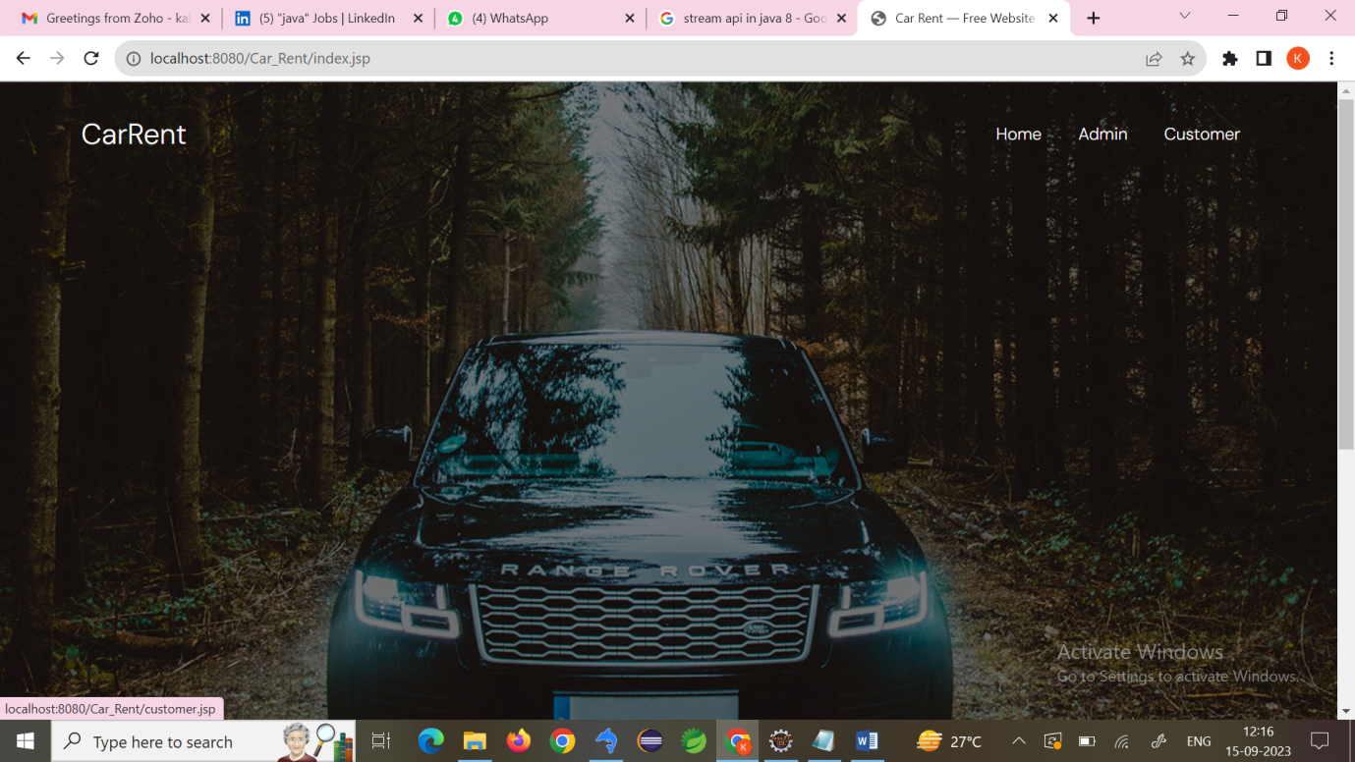

Admin:

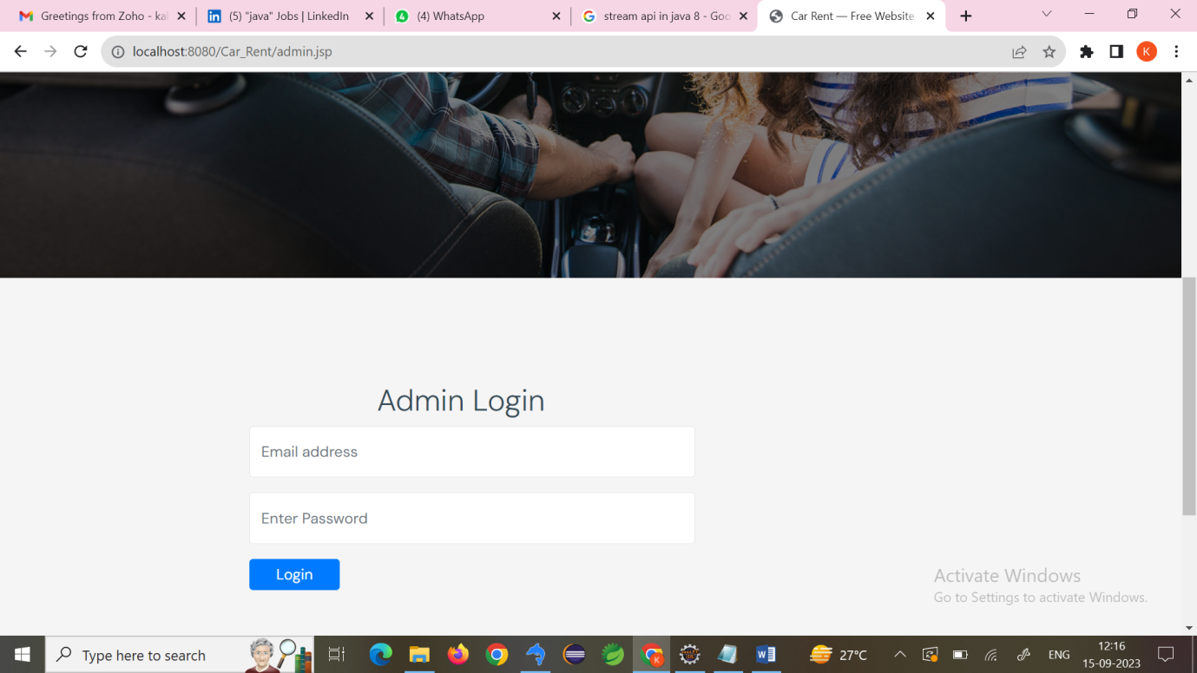

Admin Home:

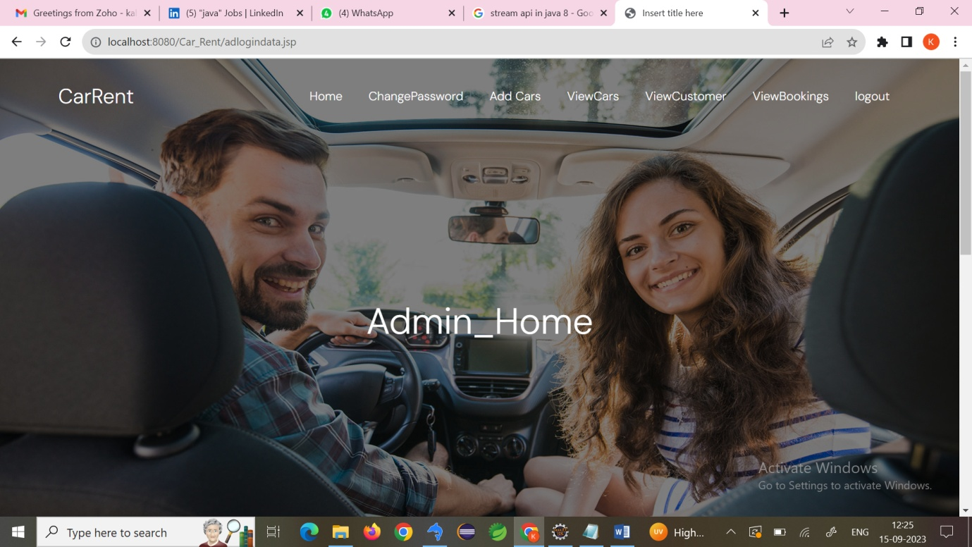

Add Cars:

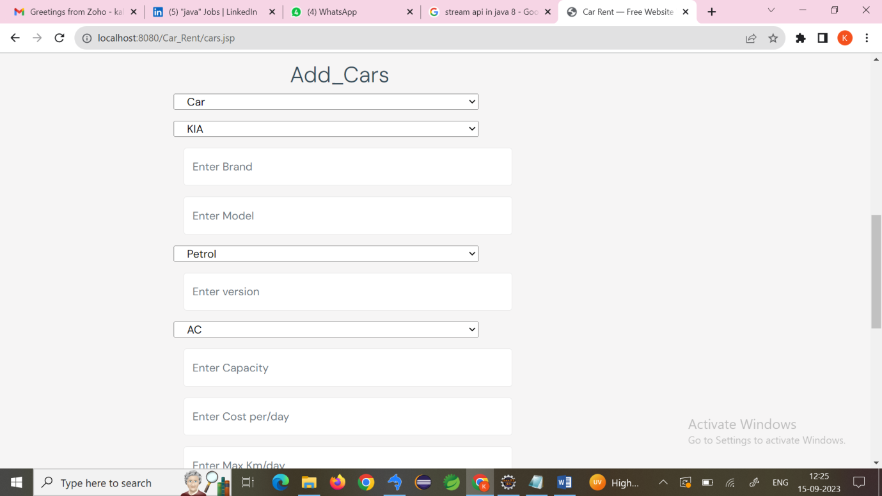

View cars:

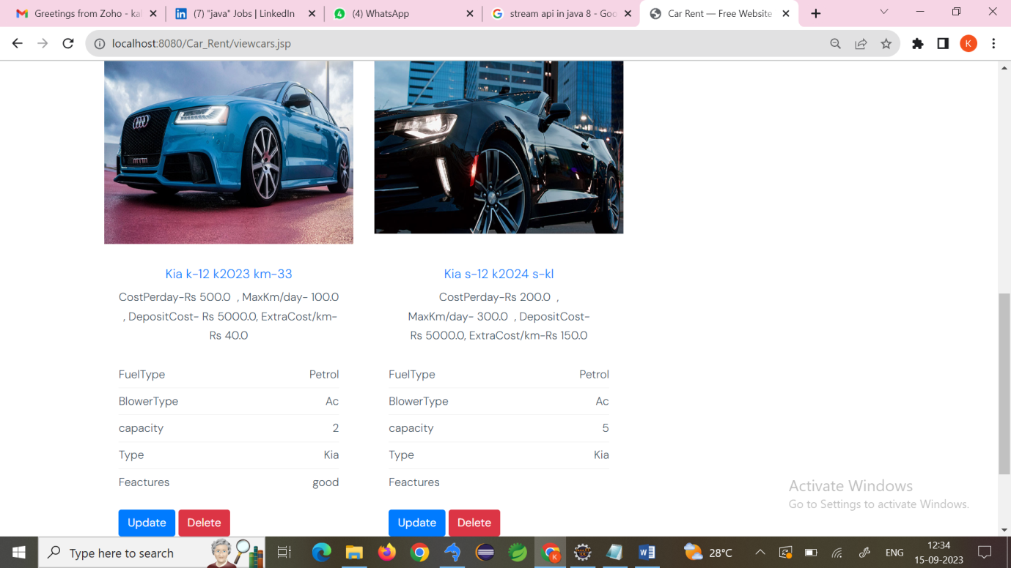

View Customers:

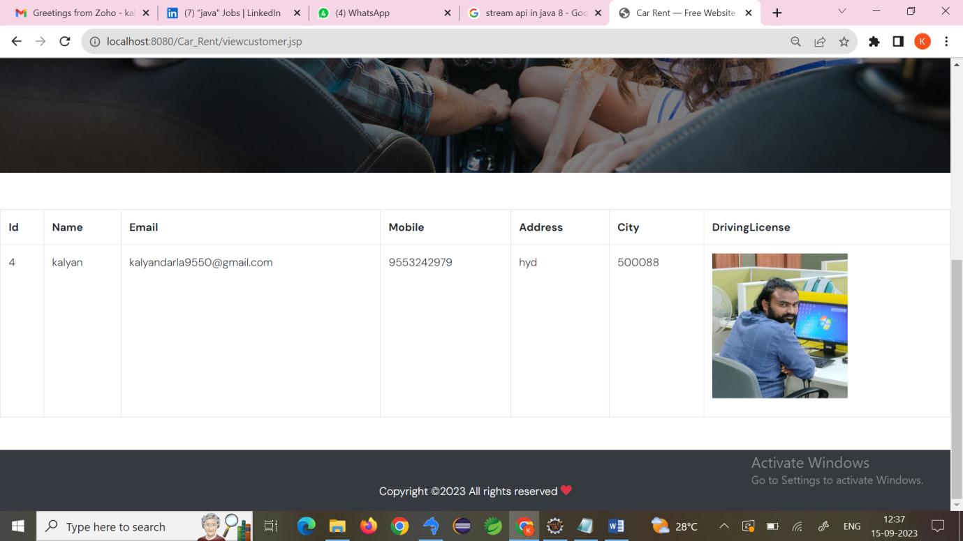

View Bookings:

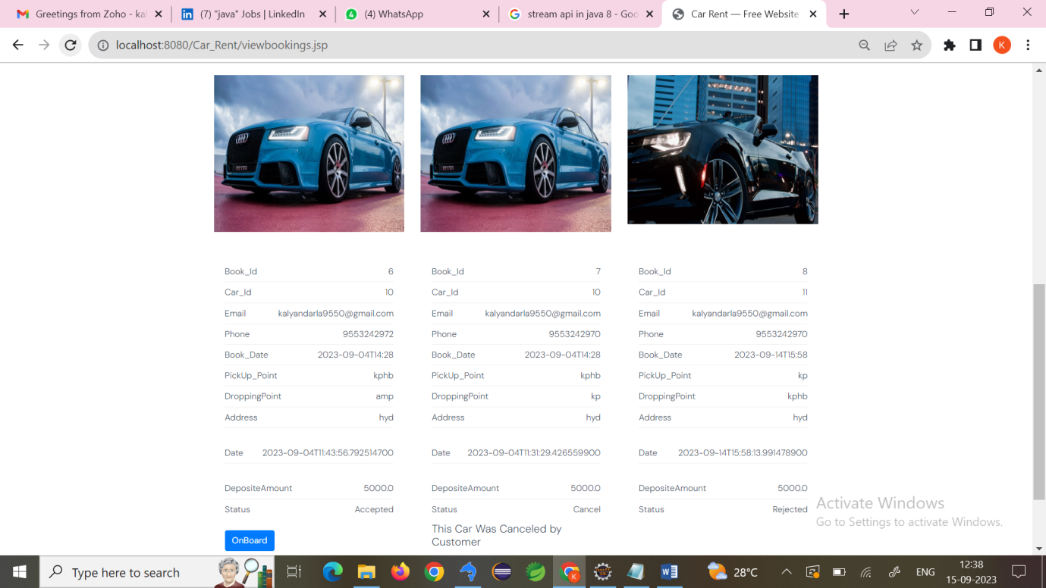

Customer login:

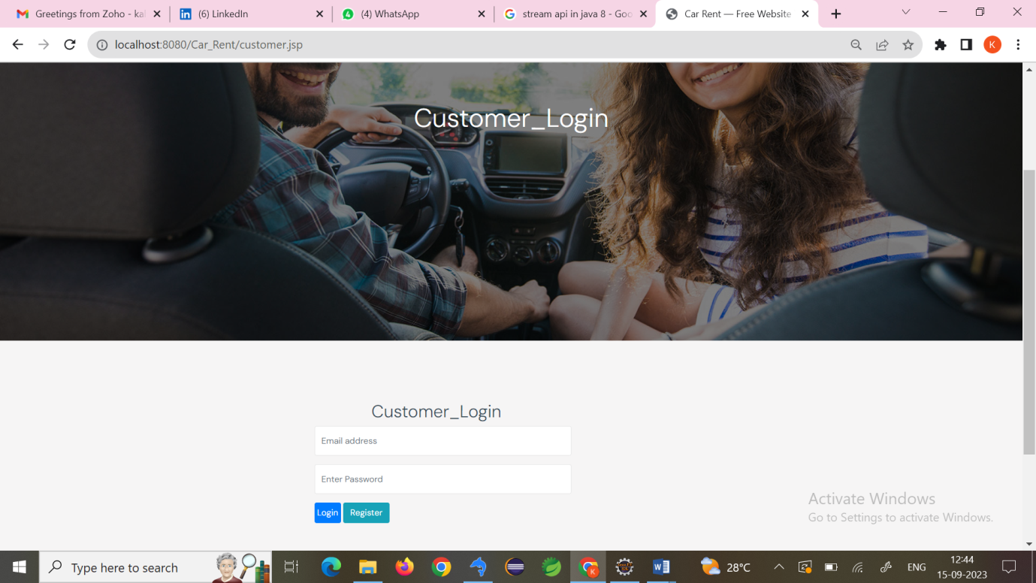

Customer registration:

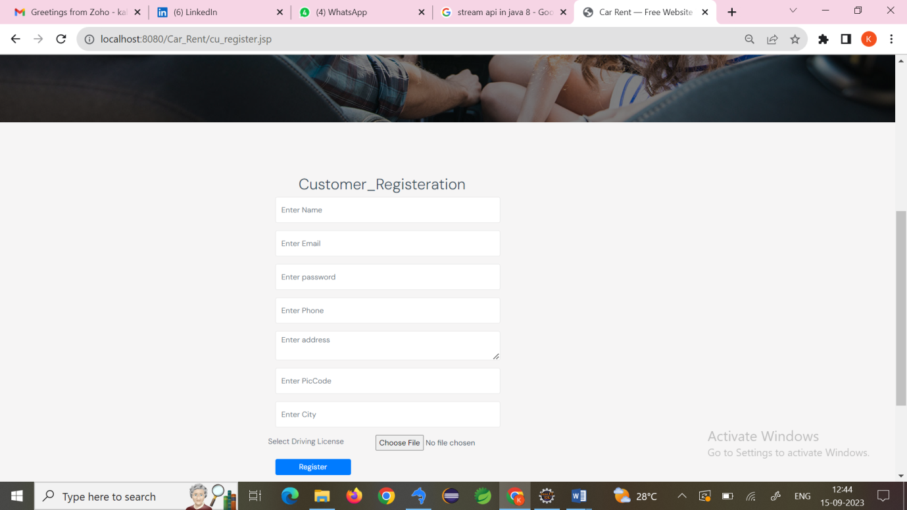

Customer home:

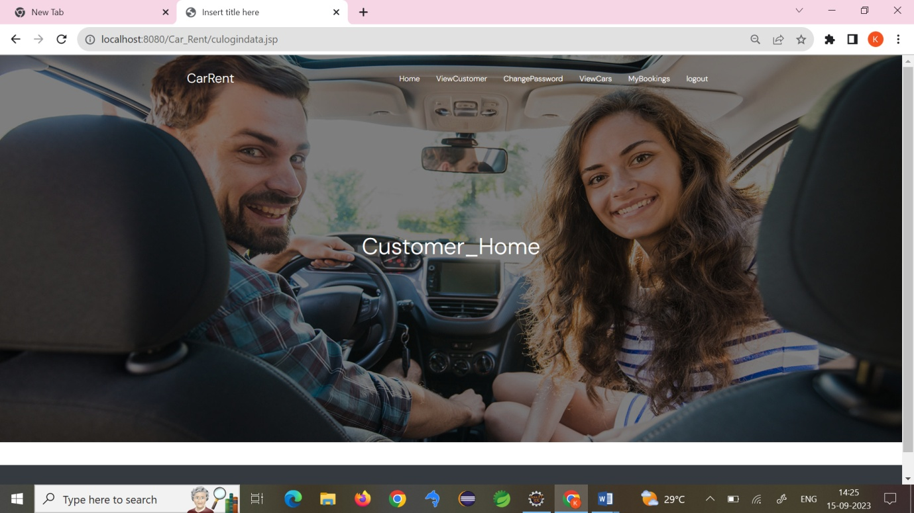

View Customers:

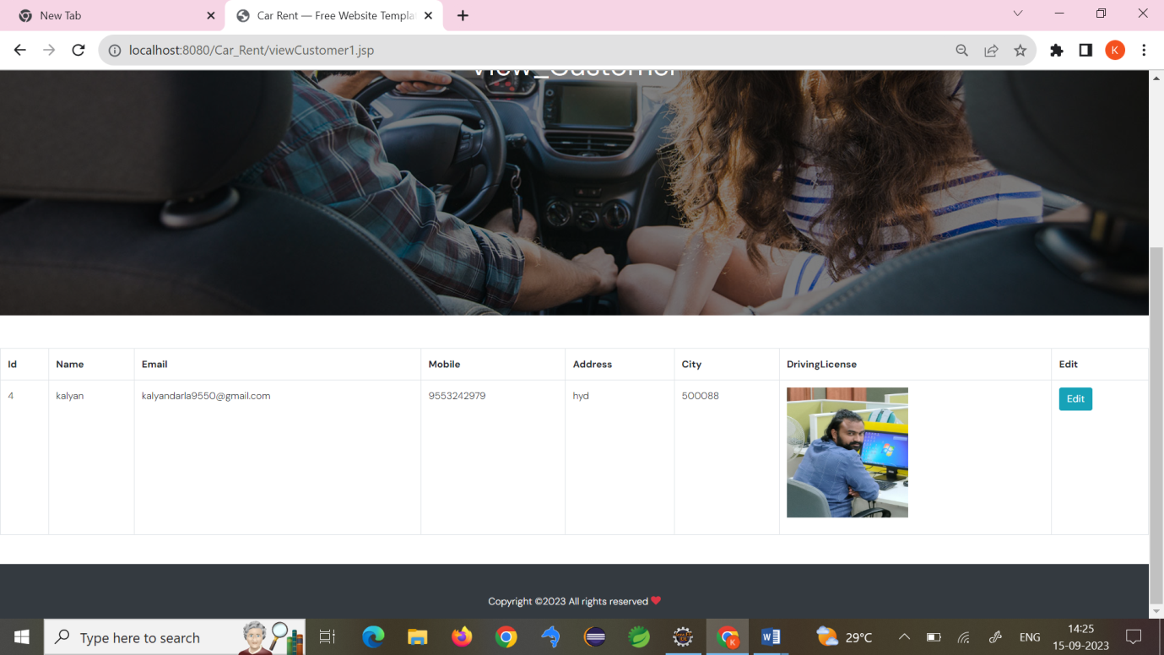

View cars:

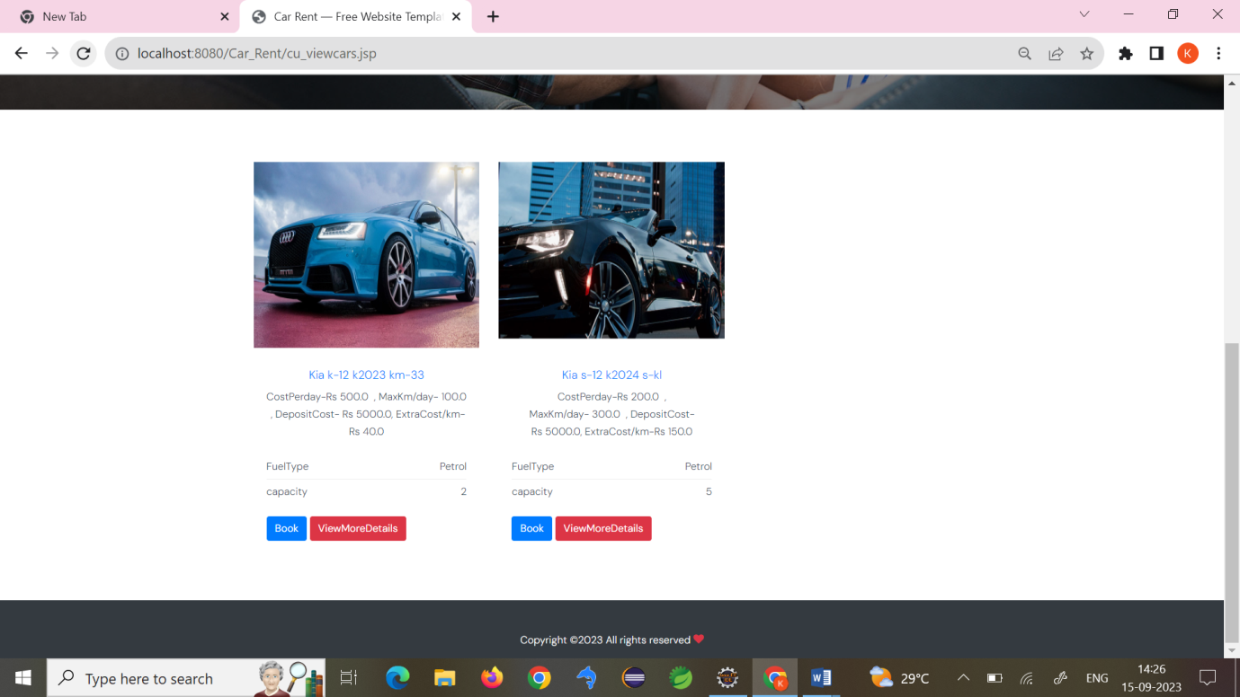

Book cars:

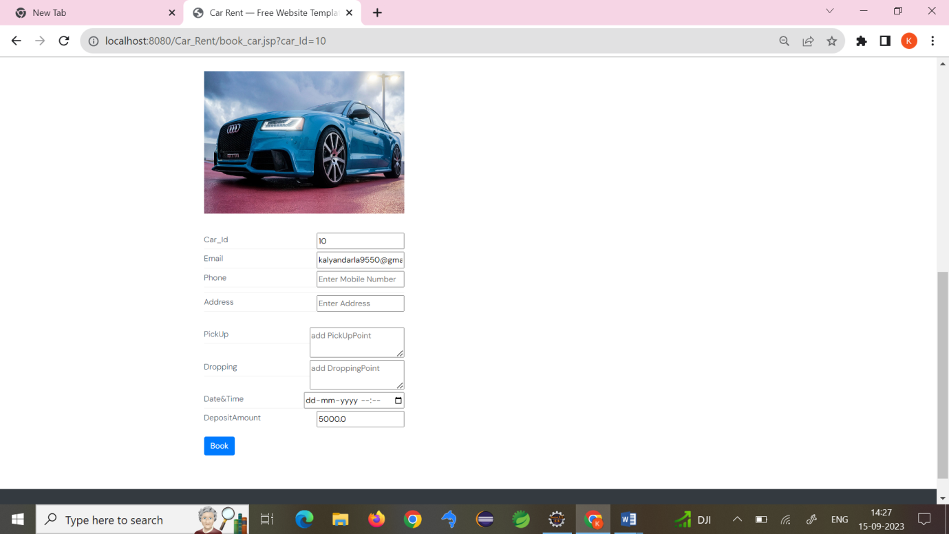

My Bookings:

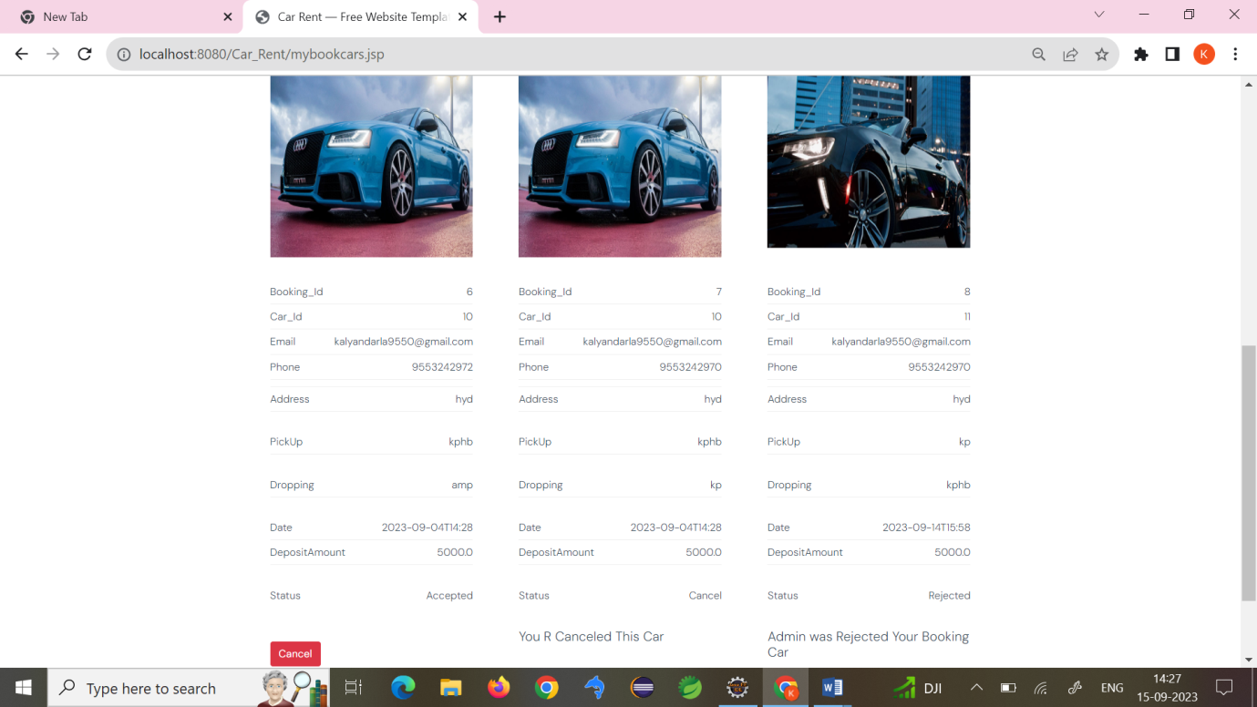

**TESTING:**

**Testing Process**

**i. Introduction**

The purpose of testing is to discover errors. Testing is the process of trying to discover every conceivable fault or weakness in a work product. It provides a way to check the functionality of components, sub assemblies, assemblies and/or a finished product It is the process of exercising software with the intent of ensuring that the Software system meets its requirements and user expectations and does not fail in an unacceptable manner. There are various types of test. Each test type addresses a specific testing requirement.

**ii. Types of Testing**

**Unit Testing**

Unit testing involves the design of test cases that validate that the internal program logic is functioning properly, and that program inputs produce valid outputs. All decision branches and internal code flow should be validated. It is the testing of individual software units of the application .it is done after the completion of an individual unit before integration. This is a structural testing, that relies on knowledge of its construction and is invasive. Unit tests perform basic tests at component level and test a specific business process, application, and/or system configuration. Unit tests ensure that each unique path of a business process performs accurately to the documented specifications and contains clearly defined inputs and expected results.

**Integration Testing**

Integration tests are designed to test integrated software components to determine if they actually run as one program. Testing is event driven and is more concerned with the basic outcome of screens or fields. Integration tests demonstrate that although the components were individually satisfaction, as shown by successfully unit testing, the combination of components is correct and consistent. Integration testing is specifically aimed at exposing the problems that arise from the combination of components.

**System Testing**

System testing ensures that the entire integrated software system meets requirements. It tests a configuration to ensure known and predictable results. An example of system testing is the configuration oriented system integration test. System testing is based on process descriptions and flows, emphasizing pre-driven process links and integration points.

**User Acceptance Testing (UAT)**

User Acceptance Testing (UAT), or application testing, is the final stage of any software development or change request lifecycle before go-live. UAT meaning the final stage of any development process to determine that the software does what it was designed to do in real-world situations. Actual users test the software to determine if it does what it was designed to do in real-world situations, validating changes made and assessing adherence to their organization’s business requirements. The main purpose of acceptance testing is to validate end-to-end business flow.

User Acceptance Testing is a testing methodology where clients/end users participate in product testing to validate the product against their requirements. It is done at the client’s site on the developer’s site. For industries such as medicine or aerospace, contractual and regulatory compliance testing, and operational acceptance tests are also performed as part of user acceptance tests. It can be done in two levels i.e alpha testing and beta testing.

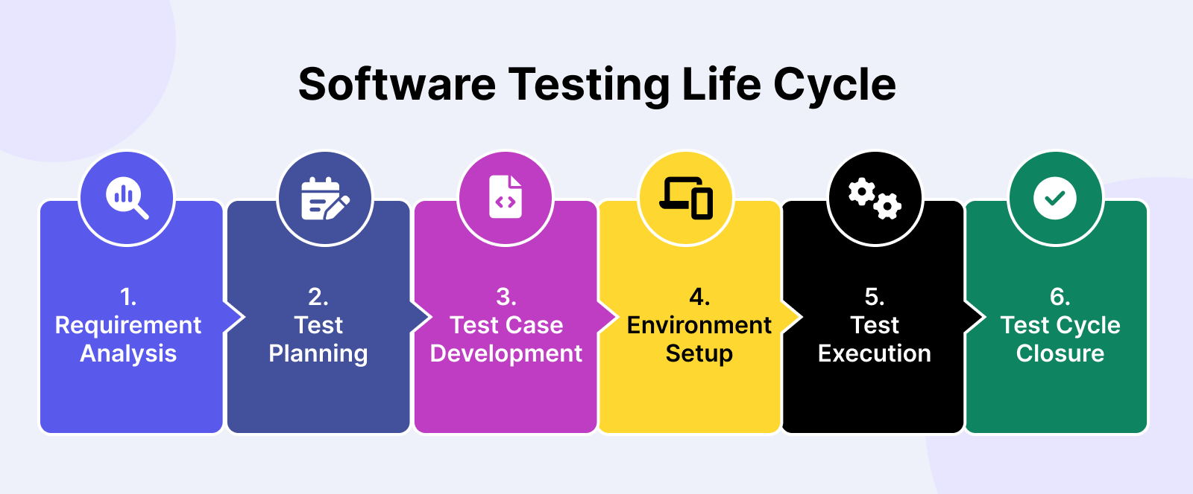

**Functional Testing**

Functional tests provide systematic demonstrations that functions tested are available as specified by the business and technical requirements, system documentation, and user manuals. Organization and preparation of functional tests is focused on requirements, key functions, or special test cases. In addition, systematic coverage pertaining to identify Business process flows; data fields, predefined processes, and successive processes must be considered for testing. Before functional testing is complete, additional tests are identified and the effective value of current tests is determined.

**Non Functional Testing**

Non functional testing is a type of software testing that verifies non functional aspects of the product, such as performance, stability, and usability. Whereas functional testing verifies whether or not the product does what it is supposed to, non functional testing verifies how well the product performs.

**White Box Testing**

White Box Testing is a testing in which in which the software tester has knowledge of the inner workings, structure and language of the software, or at least its purpose. It is purpose. It is used to test areas that cannot be reached from a black box level.

**Black Box Testing**

Black Box Testing is testing the software without any knowledge of the inner workings, structure or language of the module being tested. Black box tests, as most other kinds of tests, must be written from a definitive source document, such as specification or requirements document, such as specification or requirements document. It is a testing in which the software under test is treated, as a black box .you cannot “see” into it. The test provides inputs and responds to outputs without considering how the software works.

**Test strategy and approach**

Field testing will be performed manually and functional tests will be written in detail.

**Test objectives**

* All field entries must work properly.
* Pages must be activated from the identified link.
* The entry screen, messages and responses must not be delayed.

**Features to be tested**

* Verify that the entries are of the correct format
* No duplicate entries should be allowed
* All links should take the user to the correct page.

**iii. Test Cases**

|  |  |  |  |
| --- | --- | --- | --- |
| Testcase Id | Objective | Description | Expected Result |
| log001 | To test the URL | 1)Enter URL 2)Open the webpage 3)Check for GUI | Login validation page should open |
|  |  |  |  |
| log002 | To test the GUI | 1)open the webpage 2) check the GUI components | It should display webpage with label,email,password,submit…etc |
|  |  |  |  |
| log003 | To validate the Login page | 1)Open the login page 2)keep empty the input elements 3)click on login button | It should display error message as "Please enter email and password". |
|  |  |  |  |
| log004 | To validate the login page | 1)Open the login page 2)Enter valid credentials 3)click on login button | It should display message as "Login successfully ". |
|  |  |  |  |
| mv005 | To validate the mobile number | 1)Open the login page 2)Enter mobile with less than 10 digits 3)click on login button | It should display error message as "Please enter mobile number with 10 digits". |
|  |  |  |  |
| mv006 | To validate the mobile number | 1)Open the login page 2)Enter mobile with greater than 10 digits 3)click on login button | It should display error message as "Please enter mobile number with 10 digits". |
|  |  |  |  |
| mv007 | To validate the mobile number | 1)Open the login page 2)Enter mobile number starts with 6,7,8,9 digits 3)click on login button | It should sent OTP to the respective mobile number |
|  |  |  |  |
| mv008 | To validate the mobile number | 1)Open the login page 2)Enter mobile number doesnot starts with 6,7,8,9 digits 3)click on login button | It should display error message as "Please enter mobile number strats with 6,7,8,9 digits". |
|  |  |  |  |
| mv009 | To validate the mobile number | 1)Open the login page 2)Enter mobile number with special characters 3)click on login button | It should display error message as "Please enter mobile number with valid digits |
|  |  |  |  |

**Test Results :** All the test cases mentioned above passed successfully. No defects encountered.

**Conclusion**

With web-based rental management information system, hassle free renting can be provided. There is efficiency in paper procurement for charging the product. The data of all the products is stored in a centralized manner and the costs can be controlled and monitored by the operational manager and owner thus avoiding the over-budgeting. Data storage which is already computerized will ease the process for companies and the users for performing pre-processing, recognizing the buying patterns and maintaining the integrity of the data and use this information to a personal benefit. Through this application we are trying to promote renting out products used on a daily basis instead of buying and discarding them. Our application is user-friendly, open source and is Free to use. It positively impacts the environmental situation by using fewer products a greater number of times. Hiring products provides a simple way of collecting useful information to measure this service. Concentrating on customer satisfaction and the four dimensions, “Reliability”, “Responsiveness”, “Tangibles” and “Quality” helps us to serve the users in a better manner and thus give us a competitive edge over the others.

**Future Scope**

As the technology evolves, the web development industry promises noteworthy progress. We will see the industry growing and expanding with the introduction of new tools and technologies. Here is what the future of our website development are Responsive and Adaptive Designs, Payment Gateway Integration, Email / SMS Gateway integration, Mobile OTP Integrations, and also we can enhance this web application to mobile users by developing same application into mobile technology like android, IOS. So that user can use same application features even in mobile devices also. And also we can add GPS or location based services. You can even enhance the application by providing ML features like recommendations, predictions and classifications etc. We can also upgrade the best search and filter mechanisms too for this website.

**References**

* + <http://www.javatpoint.com>
  + <http://www.w3schools.com>
  + <http://www.stackoverflow.com>
  + **https://docs.oracle.com/javase/tutorial/java/index.html**
  + **https://www.programiz.com**
  + **https://docs.python.org/3/tutorial/index.html**
  + **https://www.djangoproject.com/start/**
  + **https://www.geeksforgeeks.org/django-tutorial/**
  + **https://www.umsl.edu/~siegelj/CS4010/murach/Chapter1slides.pdf**
  + **https://github.com/**